Homology Modeling Exercise

We will investigate the structure of the influenza virus neuraminidase protein and look at how its function may be blocked by using the neuraminidase inhibitor oseltamivir, the active ingredient in the drug Tamiflu.

- The substrate of influenza virus neuraminidase is sialic acid. The structures of sialic acid and the drugs oseltamivir (in Tamiflu) and zanamivir (in Relenza) are shown below (from P.J. Collins et al., Nature 453, 1258 (2008)).

Briefly describe the similarities and differences between enzyme substrate, sialic acid, and the enzyme inhibitors.

- The structure of an N2 neuraminidase with sialic acid bound in the active site can be found in the PDB entry 2BAT. A N1 neuraminidase with the active site blocked by oseltamivir can be found in 2HU4. Some naturally occurring mutated variants of viral neuraminidase have been found to give rise to Tamiflu-resistant strains of influenza. One such mutant is avian influenza N1 His274Tyr. According to P.J. Collins et al. (Nature 453, 1258 (2008)), this mutant binds oseltamivir with much lower affinity than the wild-type enzyme. Enzyme inhibition is reduced by a factor ~265. The structure of oseltamivir bound to His274Tyr N1 neuraminidase can be found in the PDB-structure 3CL0.

Download the “PyMOL scene” or “PyMOL session” from this website http://folk.uio.no/jonkl/pubstuff/NeuraminidasesExc4.pse. Save the file on your Desktop and open it in PyMOL. This PyMOL session contains:

- 2HU4, chain A: A wild-type N1 neuraminidase bound to oseltamivir (green)
- 2BAT, chain A: A wild-type N2 neuraminidase bound to sialic acid (blue)
- 3CL0, chain A: A His274Tyr N1 mutant bound to oseltamivir (yellow)

- The proteins are shown in cartoon rendering and the ligands as sticks. You could easily have generated this “scene” yourself (and saved it as a PyMOL session), but we do not have time for that now! Actually, if you have used PyMOL a bit before and have the time, please download the PDB files and get the 3 structures into the same session. That is, do it “properly”.

It is much easier to see similarities and differences if we align the structures in 3D space. Type “align 2HU4, 2BAT” (watch the screen as you tap “enter”!) to make a superimposition of these two structures. This is PyMOL’s variant of intermolecular alignment. One of the structures is translated and rotated in order to get the lowest possible RMSD with respect to the other. Which of the two structures were moved?

- Align also 3CL0 with the two others. Does sialic acid and oseltamivir bind in the same pocket on the enzyme surface? Would you describe the structures as identical? Similar? Dissimilar?

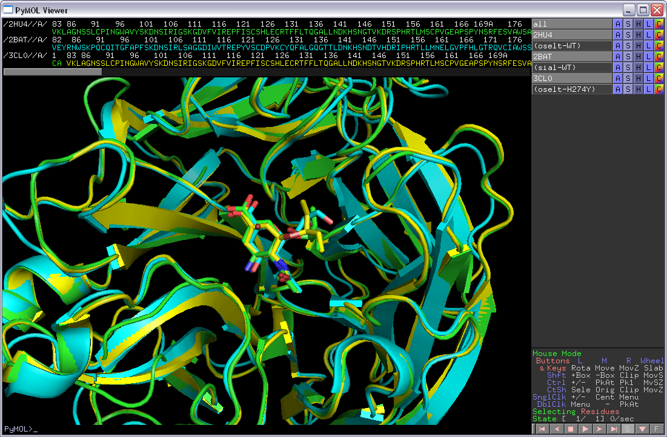

- We will now look at 2HU4 only. Turn off the two other objects in the mini-menu on the right-hand side of the viewer window. You now see only wild-type N1 neuraminidase bound to oseltamivir in the active-site pocket.

- “oselt-WT” is a selection containing only the oseltamivir molecule. Click on the selection to get that confirmed. Make a new selection containing only residues within 8 Å of oseltamivir, i.e. the “active-site region”. To do this type “select ActSite, oselt-WT around 8”. Hide everything and then show both oseltamivir and ActSite as “sticks”. Color them “by element” but use different colors for the C-atoms making it easy to see both the oseltamivir and the protein residues. Hide everything else. You should now be able to see all the residues of the neuramidase packing around oseltamivir (as seen below).

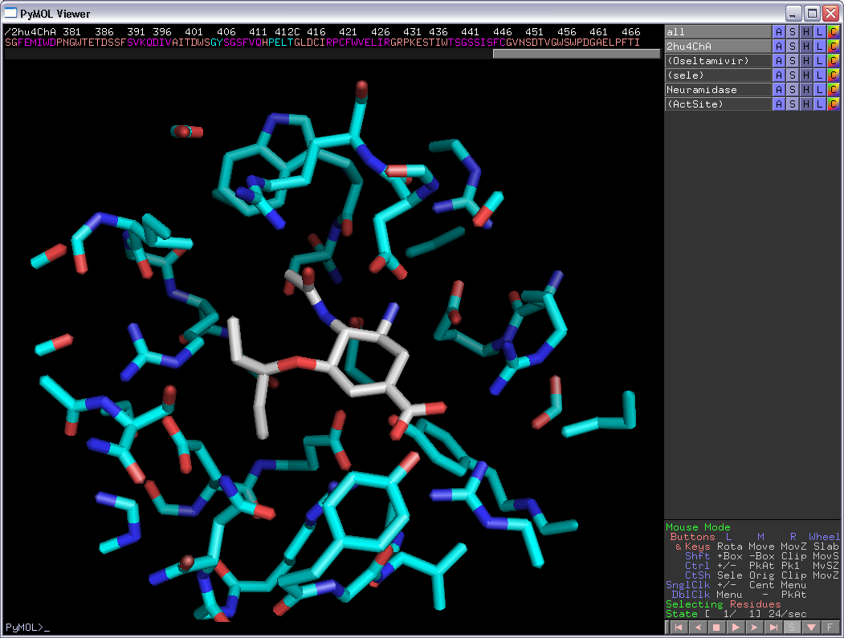

- For the (ActSite) selection, do “L” → “residues” to get these residues labeled.

- You can let PyMOL make an attempt on localizing H-bonds between oseltamivir and the protein by doing for the (oselt-WT) selection: “Actions” → “find” → “polar contacts” → “to other atoms in object”. As you see, there are too many H-bonds, but at least you get some idea.

- List two acidic residues forming H-bonds to oseltamivir. Which basic residue is donating an H-bond to the amide group of oseltamivir? Two other basic residues contact the carboxyl group of oseltamivir. Which are they? One of them is even involved in strong, so-called “bidentate” H-bonding. Which one? List some other residues involved in van der Waals interactions packing with oseltamivir.

- Turn on all three objects again, 2HU4, 2BAT, and 3CL0. Find residue 274 in the three structures. Show them as sticks. What are they? What can you say about the properties of these residues?

- Color the three objects differently, but “by element”. Now you see the (aligned) active site residues of the three enzymes.

- Above you have identified several residues involved in forming H-bonds with oseltamivir: Glu119, Asp151, Arg152, Arg292 and Arg371. Are these residues conserved in all three neuraminidases? What can you say about the conformations/rotamers of the side chains for these residues? Why do you think these residues are conserved? What would happen if for example the mutation Glu119Trp was introduced? Would the enzyme be inhibited by oseltamivir? Would it have any activity on sialic acid? Can you find any active site residues that are not conserved between the three neuraminidases?

- Locate residues 274 and Glu276. Take a closer look at the conformation of Glu276 in the 3 structures. Are you able to explain why the His274Tyr mutant binds oseltamivir less efficiently than the wild-type enzyme? Can you explain why His274Tyr is “allowed”, i.e. the enzyme has wild-type activity on its substrate? Why is this mutation particularly good for the virus and bad for the doctor trying to treat a patient with Tamiflu?

Now let us try some modeling!

- You have a cousin working for Médecins Sans Frontières near Goroka in Papua New Guinea. You get this e-mail from her:

Dear cousin,
we have some serious problems here with an outbreak of an influenza-like disease. We have high mortality rates and it appears to be highly contagious. We have some indications that this might be an oseltamivir-resistant strain of influenza. I remember you told me about that bioinformatics course and perhaps you can help me with some quick modeling. It will be much faster than going to the lab and we are certainly in a hurry here :-(

Through another contact we managed to get the neuraminidase gene from this virus sequenced:

>Possible neuraminidase [Putative influenza A virus (Goroka)]
MNPNQKILTIGSVSLSIATICFLMQIAILVSTVTLHFKQYECNSPPQNQVMLCDPTIIERNITEIVYLTNTT
IEREICPRLAEYKNWTRPQCDISGFAPYSKDNSIRLSAGGDIWVIREPYLSCDPDKCYQFILGQGSTLNNVH
SNDTVHDRTPYRTLMMNELGVPFHLGTKNVCIAWSTSSCHDGKAWLHVCVMGDDKNASATFIYNGRLVDSIV
SWSRKILRTQESECVCINGSCTVVMQDGSASGKADTKILFIEDGKILHTSTLSGSAQHVEECSCYPRYPGVK
CVCRDNWKGSNRPLVDINIDYSIVTSYVCSGLIGDTPRRNDSSSSSHCLDPQNEEGGHGVKGWAFDDGNDVW
MGRTISEKLRSGYESFKVIEGWSKPNSKLNIRQVIVERGNRSGYSGIFSVEGRSCINRCFYVELIRGRKDET
EVLWTSSSIVVFCGTSGTYGTGSWPDGADL

Can you have a look at this and give me feedback? Can structural bioinformatics tell us anything about this strain? Might it be resistant to Tamiflu?

Please help us,
Your cousin

What should you do? In this case, would you recommend trying to crystallize the protein and investigate the structure by X-ray crystallography? Why not?

You decide that you will try homology modeling for the Goroka neuraminidase. What are the 6 steps involved?

Go to the NCBI website (http://blast.ncbi.nlm.nih.gov/Blast.cgi) and do “protein blast”. Use the Goroka-sequence as a query sequence, use blastp and search the pdb-database for possible templates. Make sure you use the pdb-database, and nothing else! Do you find any templates that are suitable for homology modeling? Search for the string “2HTY” on the results page. Below the header at the sequence alignment for this hit click on “See 23 more title(s)” to find 2HU4. Is 2HU4, containing oseltamivir, a possible template? What is the sequence identity between the template 2HU4 and the target (Goroka sequence)? Does homology modeling appear to be a possibility? Will you be able to use 2HU4 for modeling the full-length protein?

- The sequence alignment you got from blastp is the following, in CLUSTAL format:

CLUSTAL

Target CDISGFAPYSKDNSIRLSAGGDIWVIREPYLSCDPDKCYQFILGQGSTLNNVHSNDTVHD
Templ CPINGWAVYSKDNSIRIGSKGDVFVIREPFISCSHLECRTFFLTQGALLNDKHSNGTVKD

Target RTPYRTLMMNELG-VPFHLGTKNVCIAWSTSSCHDGKAWLHVCVMGDDKNASATFIYNGR
Templ RSPHRTLMSCPVGEAPSPYNSRFESVAWSASACHDGTSWLTIGISGPDNGAVAVLKYNGI

Target LVDSIVSWSRKILRTQESECVCINGSCTVVMQDGSASGKADTKILFIEDGKILHTSTLSG
Templ ITDTIKSWRNNILRTQESECACVNGSCFTVMTDGPSNGQASYKIFKMEKGKVVKSVELDA

Target SAQHVEECSCYPRYPGVKCVCRDNWKGSNRPLVDINIDYSIVTSYVCSGLIGDTPRRNDS
Templ PNYHYEECSCYPNAGEITCVCRDNWHGSNRPWVSFNQNLEYQIGYICSGVFGDNPRPNDG

Target SSSSHCLDPQNEEGGHGVKGWAFDDGNDVWMGRTISEKLRSGYESFKVIEGWSKPNSKLN
Templ TGS---CGPVSSNGAYGVKGFSFKYGNGVWIGRTKSTNSRSGFEMIWDPNGWTETDSSFS

Target IRQVIVERGNRSGYSGIF----SVEGRSCINRCFYVELIRGRKDETEVLWTSSSIVVFCG
Templ VKQDIVAITDWSGYSGSFVQHPELTGLDCIRPCFWVELIRGRPKES-TIWTSGSSISFCG

Target TSGTYGTGSWPDGADL
Templ VNSDTVGWSWPDGAEL

How many indels (insertions/deletions) are there? Is getting the correct sequence alignment important for homology modeling? How could you improve the alignment?

- In order to do homology modeling for the Goroka target sequence, go to the SWISS-MODEL website (http://swissmodel.expasy.org). Click on “Start Modelling”. You can create an account, but that is not necessary for this exercise. Instead of using the default mode under “Modelling” which is the simplest (but might give more errors) we will try “Alignment Mode“. We need a good alignment to start this job. However, due to lack of time, we will try to use the alignment we got from blastp above. Open the template structure in PyMOL (for example the file
http://folk.uio.no/jonkl/pubstuff/2hu4ChA.pdb). Show as “cartoon” or “ribbon”. Locate the positions of the indels in the alignment above. Are they in loops/coils, as they should preferably be, or in helices/sheets? One of the indels is at the end of a beta strand, and we will move it into the loop after this strand by changing

Target IRQVIVERGNRSGYSGIF----SVEGRSCINRCFYVELIRGRKDETEVLWTSSSIVVFCG
Templ VKQDIVAITDWSGYSGSFVQHPELTGLDCIRPCFWVELIRGRPKES-TIWTSGSSISFCG

to

Target IRQVIVERGNRSGYSGIFSVE----GRSCINRCFYVELIRGRKDETEVLWTSSSIVVFCG
Templ VKQDIVAITDWSGYSGSFVQHPELTGLDCIRPCFWVELIRGRPKES-TIWTSGSSISFCG

Actually, what we have done here is to remove a very short alpha helix. It is only four residues and not much of an alpha helix anyway. We did this to move the indels out of the core of the protein and the main secondary structure elements. This gives us the following alignment of target and template, in CLUSTAL and FASTA format, respectively:

CLUSTAL

Target CDISGFAPYSKDNSIRLSAGGDIWVIREPYLSCDPDKCYQFILGQGSTLNNVHSNDTVHD
Templ CPINGWAVYSKDNSIRIGSKGDVFVIREPFISCSHLECRTFFLTQGALLNDKHSNGTVKD

Target RTPYRTLMMNELG-VPFHLGTKNVCIAWSTSSCHDGKAWLHVCVMGDDKNASATFIYNGR
Templ RSPHRTLMSCPVGEAPSPYNSRFESVAWSASACHDGTSWLTIGISGPDNGAVAVLKYNGI

Target LVDSIVSWSRKILRTQESECVCINGSCTVVMQDGSASGKADTKILFIEDGKILHTSTLSG
Templ ITDTIKSWRNNILRTQESECACVNGSCFTVMTDGPSNGQASYKIFKMEKGKVVKSVELDA

Target SAQHVEECSCYPRYPGVKCVCRDNWKGSNRPLVDINIDYSIVTSYVCSGLIGDTPRRNDS
Templ PNYHYEECSCYPNAGEITCVCRDNWHGSNRPWVSFNQNLEYQIGYICSGVFGDNPRPNDG

Target SSSSHCLDPQNEEGGHGVKGWAFDDGNDVWMGRTISEKLRSGYESFKVIEGWSKPNSKLN
Templ TGS---CGPVSSNGAYGVKGFSFKYGNGVWIGRTKSTNSRSGFEMIWDPNGWTETDSSFS

Target IRQVIVERGNRSGYSGIFSVE----GRSCINRCFYVELIRGRKDETEVLWTSSSIVVFCG
Templ VKQDIVAITDWSGYSGSFVQHPELTGLDCIRPCFWVELIRGRPKES-TIWTSGSSISFCG

Target TSGTYGTGSWPDGADL
Templ VNSDTVGWSWPDGAEL

>Target
CDISGFAPYSKDNSIRLSAGGDIWVIREPYLSCDPDKCYQFILGQGSTLNNVHSNDTVHDRTPYRTLMMNEL
G-VPFHLGTKNVCIAWSTSSCHDGKAWLHVCVMGDDKNASATFIYNGRLVDSIVSWSRKILRTQESECVCIN
GSCTVVMQDGSASGKADTKILFIEDGKILHTSTLSGSAQHVEECSCYPRYPGVKCVCRDNWKGSNRPLVDIN
IDYSIVTSYVCSGLIGDTPRRNDSSSSSHCLDPQNEEGGHGVKGWAFDDGNDVWMGRTISEKLRSGYESFKV
IEGWSKPNSKLNIRQVIVERGNRSGYSGIFSVE----GRSCINRCFYVELIRGRKDETEVLWTSSSIVVFCG
TSGTYGTGSWPDGADL
>Templ
CPINGWAVYSKDNSIRIGSKGDVFVIREPFISCSHLECRTFFLTQGALLNDKHSNGTVKDRSPHRTLMSCPV
GEAPSPYNSRFESVAWSASACHDGTSWLTIGISGPDNGAVAVLKYNGIITDTIKSWRNNILRTQESECACVN
GSCFTVMTDGPSNGQASYKIFKMEKGKVVKSVELDAPNYHYEECSCYPNAGEITCVCRDNWHGSNRPWVSFN
QNLEYQIGYICSGVFGDNPRPNDGTGS---CGPVSSNGAYGVKGFSFKYGNGVWIGRTKSTNSRSGFEMIWD
PNGWTETDSSFSVKQDIVAITDWSGYSGSFVQHPELTGLDCIRPCFWVELIRGRPKES-TIWTSGSSISFCG
VNSDTVGWSWPDGAEL

- Back at the SWISS-MODEL workspace now paste in the alignment of target and template in FASTA format that you find above. Wait for the possible templates to be loaded. Choose structure 2HU4, biological assembly 1, chain A, which is the structure you have looked at earlier, and click “Build Model”. Wait for the job to finish... Or actually continue further down!

- Did the “Alignment Mode” job finish? If you do not have time to wait, log into Jon’s account to get access to the results (Ask for the account name and password). Look at the “Modelling Logs” in the pull-down menu next to the picture of the model at the left. How many loops were modeled? Do they appear to be ok? Take a look at the “Quality estimates”. Which parts of the model does not seem to be of the best quality? Look at the red/blue coloring to get an idea. Is any of the problematic areas close to the active site?

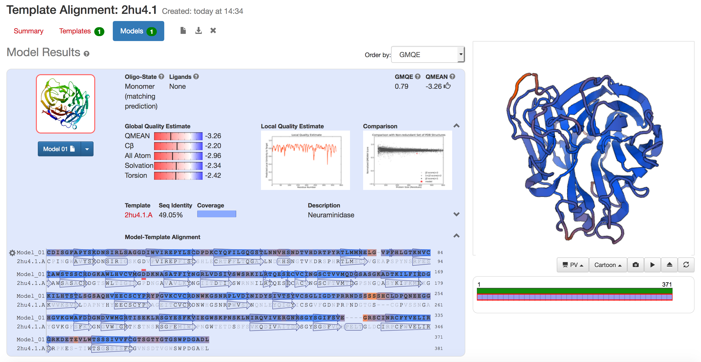

- You could have downloaded the model PDB-file to your computer, but for now, instead use a model that has been made earlier. It is the same model that you have generated with SWISS-MODEL, but in addition the modelers have used a molecular mechanics/force field program to “relax” the structure (they ran a few iterations of geometry optimization) in order to get rid of collisions between tight-packing residues. The final, “relaxed” model, aligned with the template 2HU4, chain A, is found here: http://folk.uio.no/jonkl/pubstuff/2HU4chA_GorokaTemplN1.pse. Can you locate the loops that have been modeled at the indels?

You could have checked the quality of the model at the SWISS-MODEL workspace, but we will just trust the model for now. Anyway, this model is not very good since we have used a quick and dirty alignment. But it is good enough for our task: find out if it is likely that the new virus strain can be treated with Tamiflu.

- The selection “oselt” contains the atoms of the oseltamivir inhibitor in 2HU4 chain A. Make a selection containing only residue 274 of the same chain. Rename it “274”. Color 2HU4 blue and the model yellow. Hide everything. Now type “select Actsite, oselt around 8” and “select Exten, 274 around 8”. Show both these selections as sticks and color “by element”, the first choice on the list. Do the same with “274”. Show also G39 as sticks and in a third type of “by element” coloring.

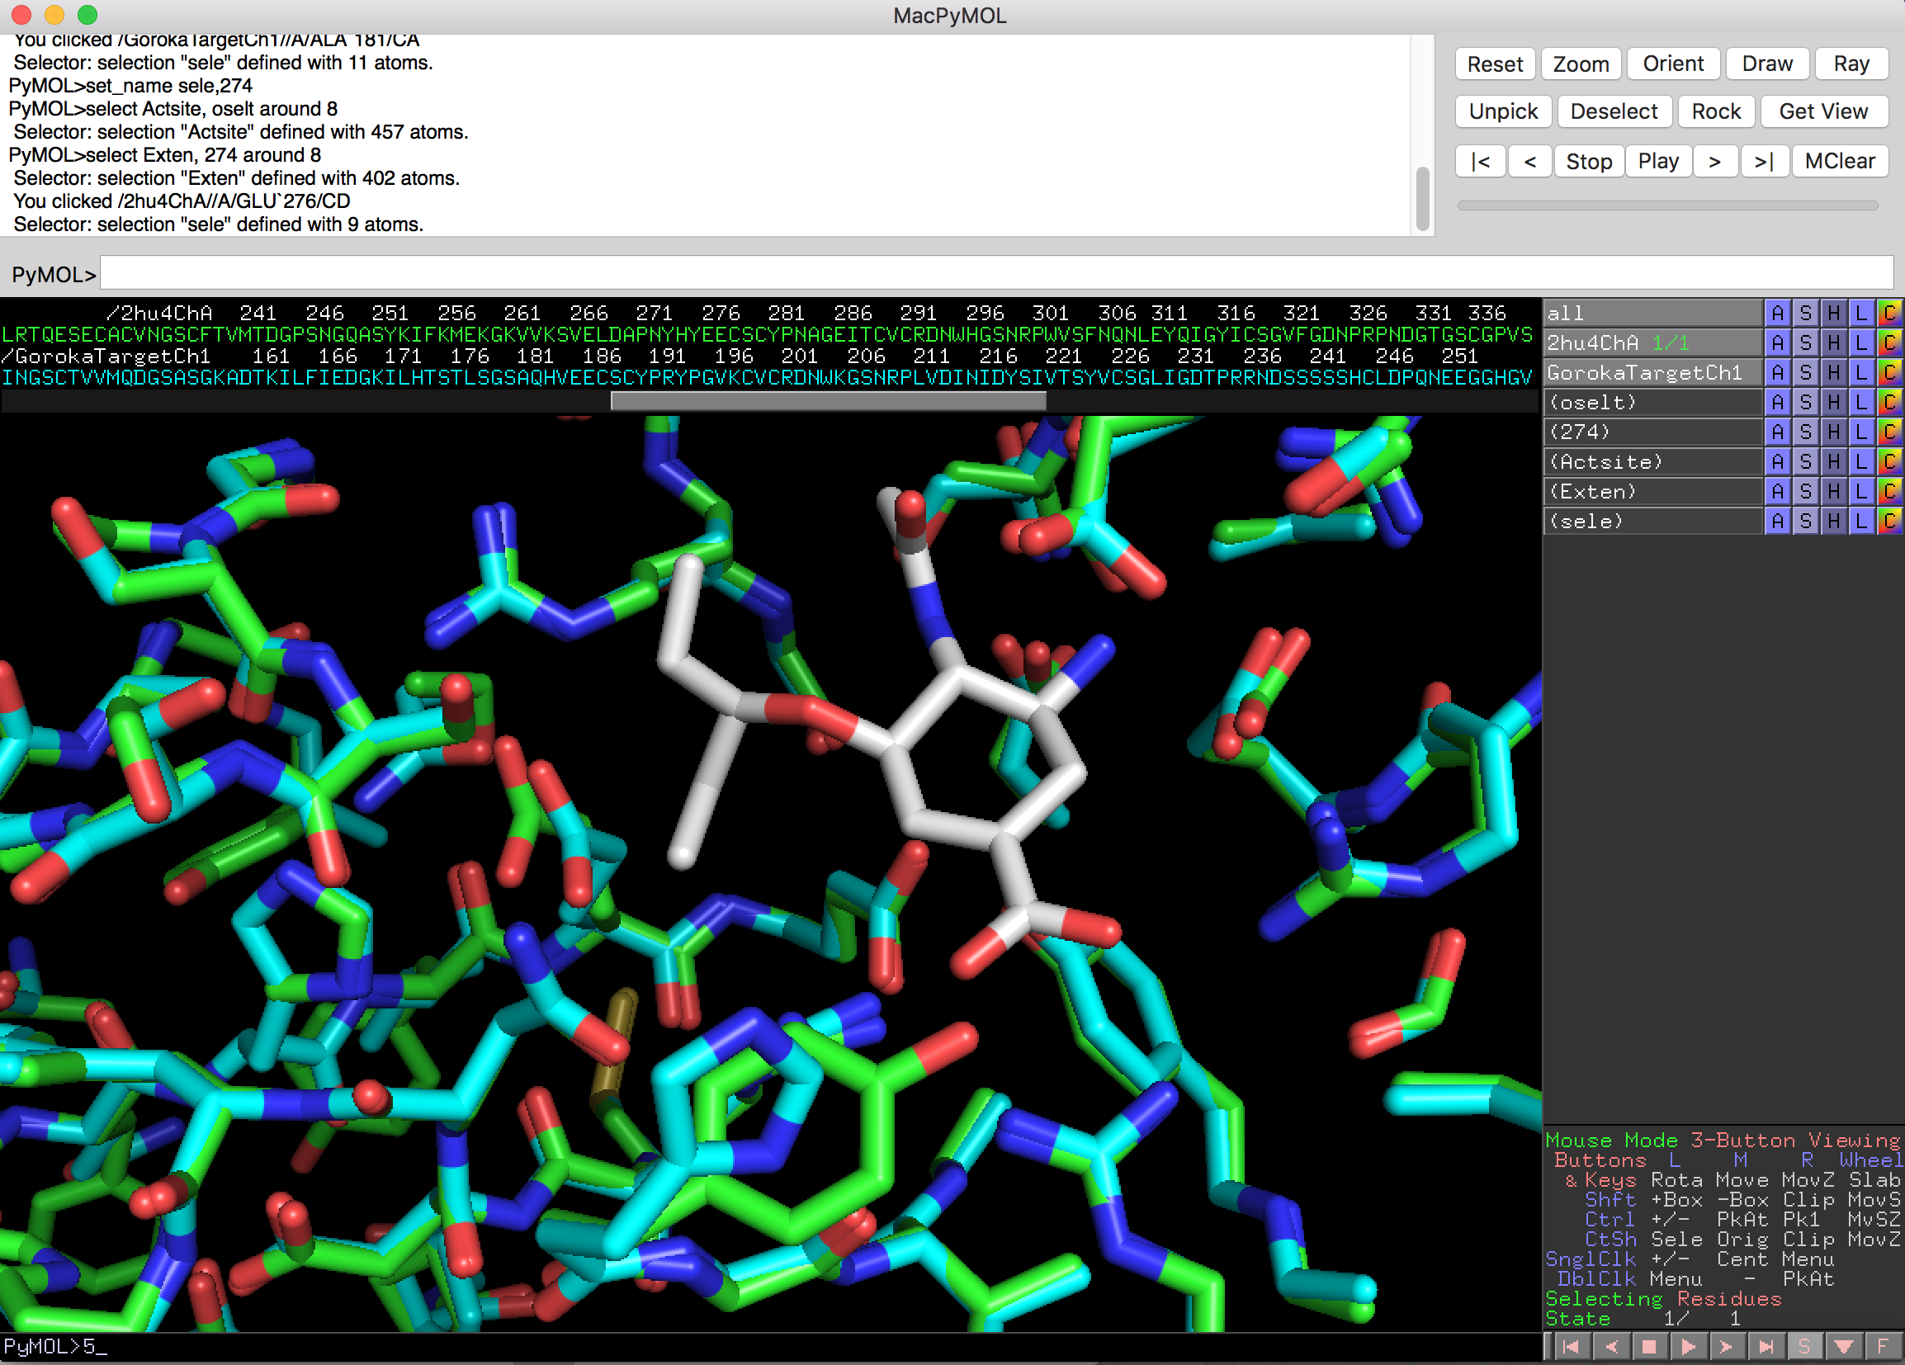

- Take a close look at the residues interacting with oseltamivir in the pocket of 2HU4 and in the model of the Goroka neuraminidase. Can you see any differences between the two structures that might explain the putative oseltamivir resistance? What do you suggest to tell your cousin?

- Find 2HU4, 2BAT, and 3CL0 in the PDB and have a look at the corresponding pdb-files in PyMOL. There are several chains in all these PDB entries. Can you say anything about the quaternary structure of neuraminidase from these structures? Do the pdb-files contain the structures of full-length proteins? Use chain A from the three pdb-files and make a session such as the one you started with in this exercise.

- Take a look at the various model quality estimation tools at the SWISS-MODEL Workspace. Is the model ok, or not. What seems to be the problem? Upload the 2HU4 chain A PDB file and run it through the same tools. Are the results any better?

- Try to improve the alignment of target and template by using the information from homologous proteins. Use the improved alignment to generate a new model for the Goroka neuraminidase. Do you get a better model?

- Do a blastp search with your favorite protein as query in the PDB sequence database. Do you find any templates that can be used for homology modeling? You might also try fold recognition, for example GenTHREADER (http://bioinf.cs.ucl.ac.uk/psipred) or Phyre2 (http://www.sbg.bio.ic.ac.uk/~phyre2).

