Sequence searching and sequence alignments – MBV-INFX410
In this exercise we will start with a bacterial DNA repair protein called Nth and identify its homologs in different species, including humans, using BLAST and PSI-BLAST, and then identify conserved sequence motifs using multiple alignments. It is a good idea to create a report document in Word (or a similar editor) were you describe briefly what you do, save the sequences that you work with and answer the questions that are asked. You must also save screen shots of what you do in your report. Make sure you know how to do this!
- Find the RefSeq protein sequence of the Endonuclease III (Nth) protein from the bacterium Escherichia coli, strain K-12, substrain MG1655, using Entrez, in the NCBI protein database (www.ncbi.nlm.nih.gov). First try yourself, without checking below!

There are many ways to do this, but what we are looking for is the RefSeq sequence NP_416150. One possibility is to search for “Escherichia coli” AND “Endonuclease III” AND MG1655 in the Protein database and then filter for RefSeq in “Source databases”. You will then have something like 13 candidates and among these the only one that is both MG1655 and “Endonuclease III” is NP_416150. Make sure you understand how you find a sequence by searching like this!

- Get the FASTA sequence for the protein and paste it into your report document.

>gi|16129591|ref|NP_416150.1| DNA glycosylase and apyrimidinic (AP) lyase (endonuclease III) [Escherichia coli str. K-12 substr. MG1655]
MNKAKRLEILTRLRENNPHPTTELNFSSPFELLIAVLLSAQATDVSVNKATAKLYPVANTPAAMLELGVE
GVKTYIKTIGLYNSKAENIIKTCRILLEQHNGEVPEDRAALEALPGVGRKTANVVLNTAFGWPTIAVDTH
IFRVCNRTQFAPGKNVEQVEEKLLKVVPAEFKVDCHHWLILHGRYTCIARKPRCGSCIIEDLCEYKEKVD
I

- Follow the link to the corresponding Gene (in the list of “Related information” at the right hand side). What is the NCBI gene identifier (Gene ID) for the gene? What is the Swiss-Prot identifier for this protein? Which genes are found directly upstream and downstream of nth? Are the three genes transcribed in the same direction?

The Gene ID is 947122 and the Swiss-Prot ID is P0AB83. The two neighbouring genes are rsxE and dtpA. All three genes are transcribed in same direction.

- In the simple genome browser on the NCBI Gene page (“Genomic regions, transcripts, and products” section) click and drag the genome to centre the region where you have the start of nth and the stop of rsxE. Then zoom in all the way to the highest possible magnification by using the slider and/or the “+” and “ATG” buttons. Make sure the start of nth stays in the middle of your browser by click-dragging, if necessary. What are the three nucleotides of the codon encoding the last (C-terminal) amino acid in rsxE? What are the nucleotides of the stop codon of rsxE and the start codon of nth? How many nucleotides are there between the start of nth and the stop of rsxE?

The last amino acid of rsxE is Val, encoded by GTC, and the stop codon is TGA. The start codon of nth is encoded by ATG. In this case the A of TGA (stop) is the same as the A of ATG (start). The two genes overlap by a single nucleotide, and there are, obviously, no nucleotides between them.

Notice how densely packed the genes are in bacteria compared to, for example, the vertebrates.

- Get the homologous sequences of the Nth protein from Mycobacterium tuberculosis strain H37Rv (GI number 57117142), Bacillus antracis strain Ames (GI number 30261643), Neisseria meningitidis strain MC58 (GI number 15676439), and Streptococcus pneumoniae strain R6 (GI number 15903200) in FASTA format, and copy them into your report.
- Edit the sequence titles to contain only the name of the bacteria and the RefSeq identifiers. Replace the spaces with the underscore character (“_”), but keep the initial larger-than character (“>”). For your first sequence, the header will then be “>Escherichia_coli_NP_416150”.
- Start Desktop JalView. Use “File” → “Input Alignment” → “from Textbox” to enter the five bacterial Nth sequences by copying and pasting. Click on “New Window”. Take a screenshot of Jalview with the input sequences and paste the image into your report.

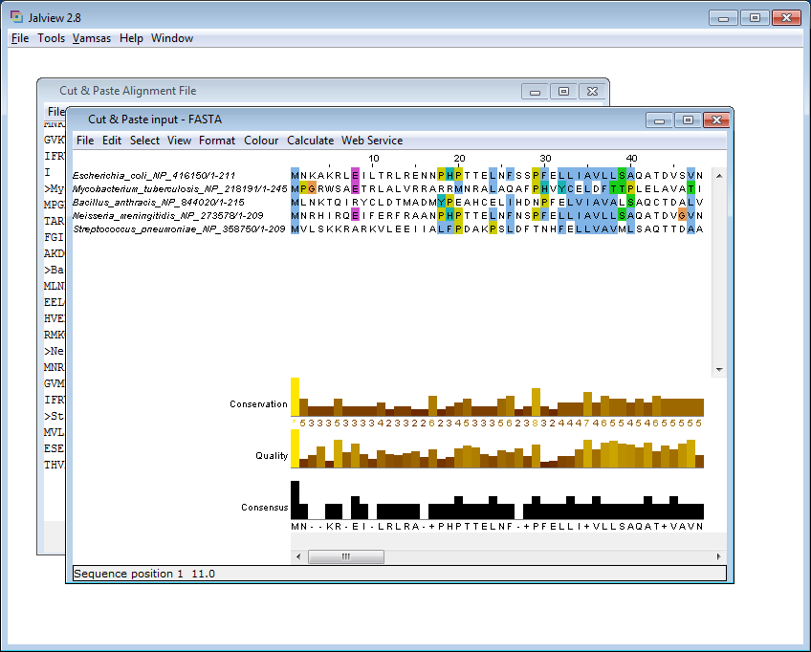

- Use the MUSCLE-algorithm web service (found under “Web Service” → “Alignment”) (with “Muscle with Defaults”) to generate a multiple sequence alignment (MSA). Can you say anything about on which computer the MUSCLE-algorithm is running? Where on the planet? Hint: Look in “Tools” → “Preferences” → “Web Services”.

The job is running as a web service on a server that at least contains the name “dundee”. The service is, very likely, running in Dundee, Scotland, on a server belonging to the group of Professor Geoff Barton. This is the group that is developing Jalview.

- Colour the amino acids according to “Percentage identity”. Remove the “Quality” annotation information in the lower part of the window by right-clicking on the word “Quality” and choose “Hide this row”. Do the same for the “Consensus” annotation. Right-click on “Conservation” and choose “Edit Label/Description”. Change the “Annotation name” to your native language. For example, in Norwegian use the text “Grad av konservering”, then click “OK”. Sort the sequences by pairwise similarity (“Calculate” → “Sort” → “By Pairwise Identity”). Reformat the alignment to make it more compact (“Format” → “Wrap”). Adjust the width of the window so that you get the MSA split into 4 lines/blocks. Also remove the tick mark at “Show Sequence Limits” under “Format”.

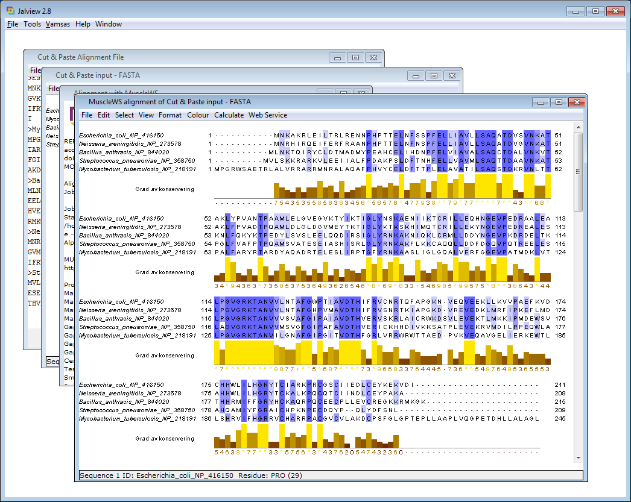

Export the alignment in PNG format, and import it into PowerPoint, Adobe Illustrator, or a similar program in order to add some extra information in the MSA. Indicate the residues involved in the helix-hairpin-helix (HhH) motif (LxGVGxK) and the [4Fe–4S] (iron sulphur) cluster motif (CxxxxxxCxxCxxxxxC). See Fig. 3 in the article below for more information about these motifs. Copy the resulting figure into your report. Are both motifs fully conserved in all sequences?

N. Goosen & G.F. Moolenaar, “Repair of UV damage in bacteria”, DNA Repair 7, 353 (2008) http://dx.doi.org/10.1016/j.dnarep.2007.09.002

The HhH motif is conserved in all species, with GVGRKTANV being fully conserved. The [4Fe-4S] cluster is conserved in all species except Streptococcus, which lacks the two last cysteines.

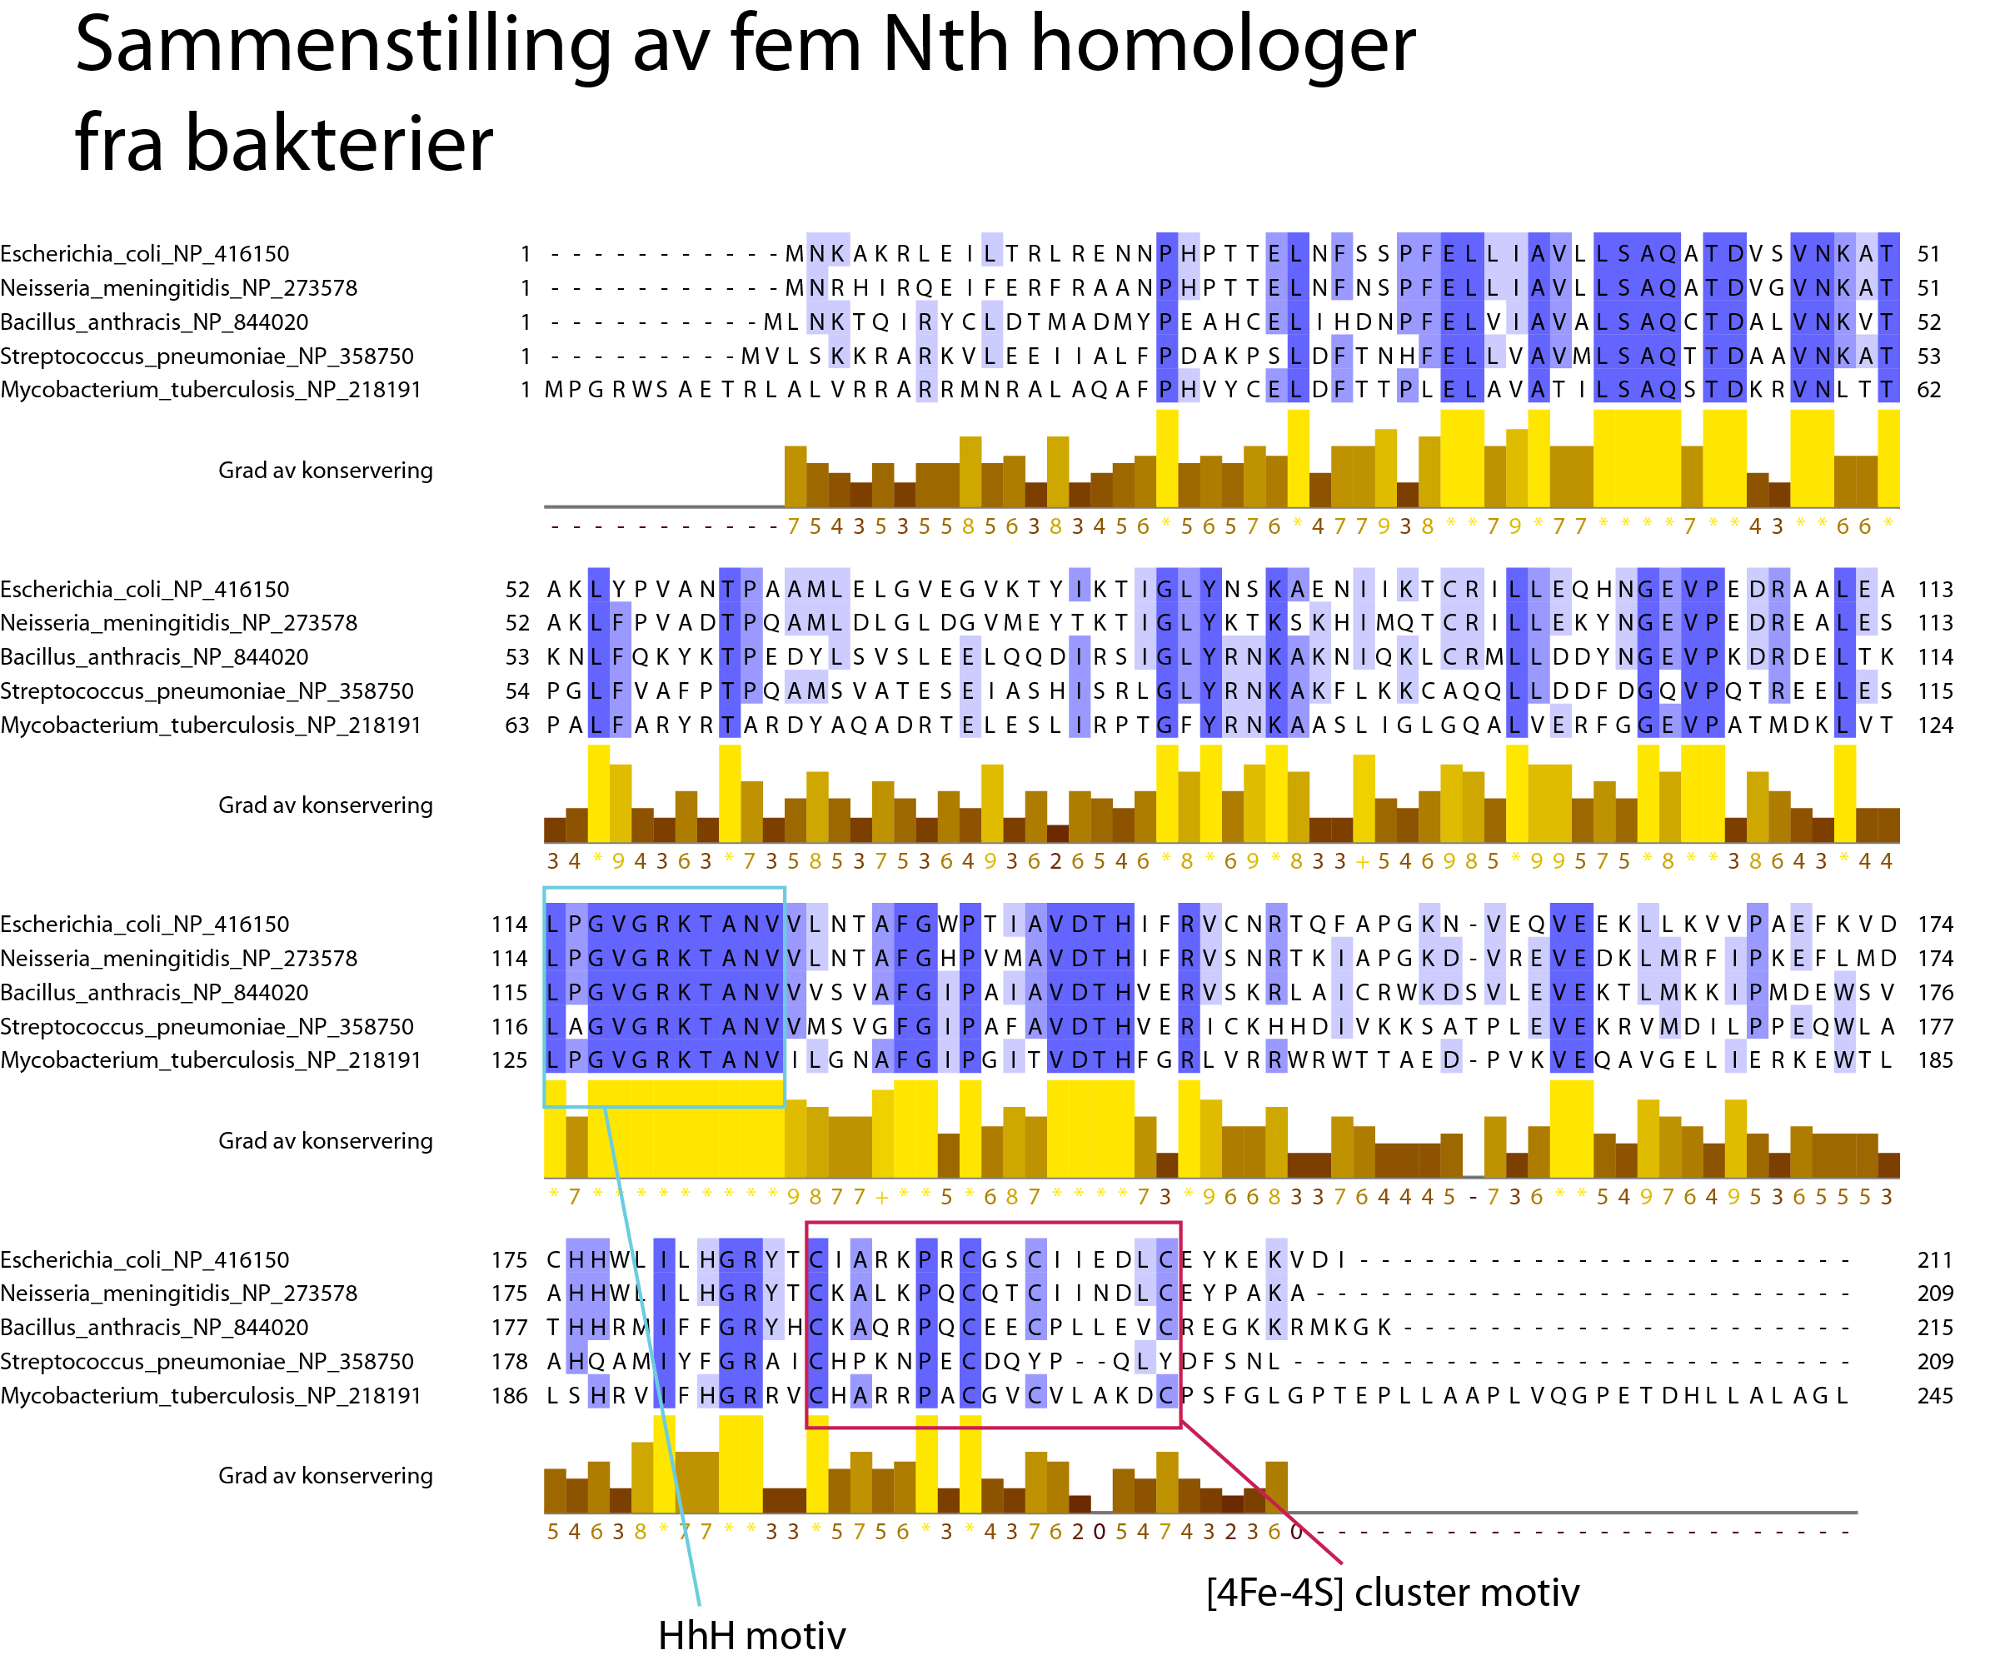

- Find the percentage sequence identity between the five sequences. First select all the sequences in the Jalview MSA window, for example by typing <ctrl>-a. Btw, if you want to select nothing, press the <Esc> key. Try this. Select all sequences again and do “Calculate” → “Pairwise Alignments…”. Look at the pairwise alignments and find which two sequences are the most similar. Which are they? What is the sequence identity between those two sequences?

E. coli and N. meningitidis are 72% identical while no other pairs are above 47%

- Using the sequence from E. coli Nth as query, perform a protein BLAST (blastp) search at the NCBI website (http://blast.ncbi.nlm.nih.gov). Use “Basic BLAST” and “protein blast” and search in the RefSeq protein database. Limit the search to protein sequences from vertebrates. Set the max target sequences options to 500 under algorithm parameters. Why do we choose blastp in this case and not tblastn?

We are searching with a protein query sequence in a protein sequence database, hence blastp. tblastn is used for searching with a protein sequence in a translated nucleotide database.

- From the resulting BLAST hits, select the following sequences: endonuclease III-like (Nth) (approx. 280-360 amino acids) and A/G-specific adenine glycosylase (also known as MutY) (approx. 510-720 amino acids) from man (Homo sapiens), mouse (Mus musculus), cow (Bos taurus), chicken (Gallus gallus), frog (Xenopus tropicalis), and the fugu pufferfish (Takifugu rubripes). If there are several isoforms of the proteins, choose the one with the lowest isoform number. Also, if there are several entries for the same protein, select the one who has an accession starting with “NP_”, or alternatively with “XP_”. We do not have time to look very closely at all the sequences and their splice variants, but if we wanted to do serious work with these sequences, we would have to do that. Retrieve the sequences in FASTA format, and paste them into the report. Make sure you are able to do this properly, at least for human, mouse, and cow, before you continue below.
- We want, as for the bacterial protein sequences, to shorten each sequence title to contain only the species name and RefSeq identifier. We could do this manually, in a text editor, as we did above for the bacterial homologs. However, the task here will be to use a little program or script to do this. If we had hundreds of sequences, making a script would certainly be quicker and less error prone. If we had even more sequences, a script would be the only option.

Log onto freebee.abel.uio.no, and create a new directory that you will work in. Download the zipped tarball MSA_exercise.tar.gz and put it in the new directory. Uncompress the file and extract all the files from the tarball.

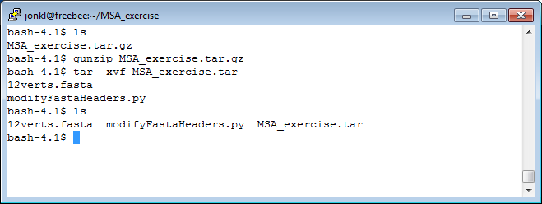

- You find the 12 vertebrate Nth homologs in the file 12verts.fasta. Make sure the file has correct Unix format with Unix end-of-lines by using cat -ve. Use man cat to find out what the “-ve” is doing. If the end-of-lines are not correct, fix the problem with the command dos2unix.

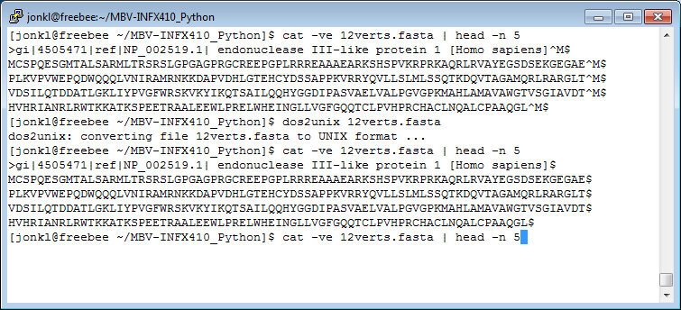

- Your task is to open the file 12verts.fasta and change all headers to the correct format (e.g. “>Homo_sapiens_NP_002519” for the human Nth homolog). Change all spaces to “_” and, of course, keep the initial “>”. Then write out a new Fasta file, identical to the original one, but with modified and simplified Fasta headers. Call the new file 12verts_new.fasta.

>gi|4505471|ref|NP_002519.1| endonuclease III-like protein 1 [Homo sapiens]
MCSPQESGMTALSARMLTRSRSLGPGAGPRGCREEPGPLRRREAAAEARKSHSPVKRPRKAQRLRVAYEGSDSEKGEGAE
PLKVPVWEPQDWQQQLVNIRAMRNKKDAPVDHLGTEHCYDSSAPPKVRRYQVLLSLMLSSQTKDQVTAGAMQRLRARGLT
...

should become

>Homo_sapiens_NP_002519
MCSPQESGMTALSARMLTRSRSLGPGAGPRGCREEPGPLRRREAAAEARKSHSPVKRPRKAQRLRVAYEGSDSEKGEGAE
PLKVPVWEPQDWQQQLVNIRAMRNKKDAPVDHLGTEHCYDSSAPPKVRRYQVLLSLMLSSQTKDQVTAGAMQRLRARGLT
...

and so on.
- Write down the steps, or a little flowchart, that shows what the script has to do in order to solve the task.
- If you have done any programming before or you want a challenge, choose (a) below, otherwise do (b).
  - Make a script in a programming language of your own choice that does the file conversion described above
  - Take a look at the python script modifyFastaHeaders.py you found in the tarball MSA_exercise.tar.gz. Go through it step by step and make sure you understand what it will do. Use this script to do the file conversion

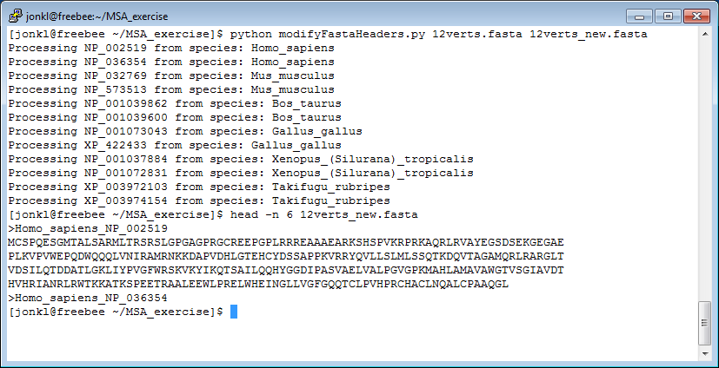

- As you did for the bacterial sequences, use Jalview to generate an MSA for the twelve vertebrate sequences, but this time use the T-Coffee algorithm (with default settings).

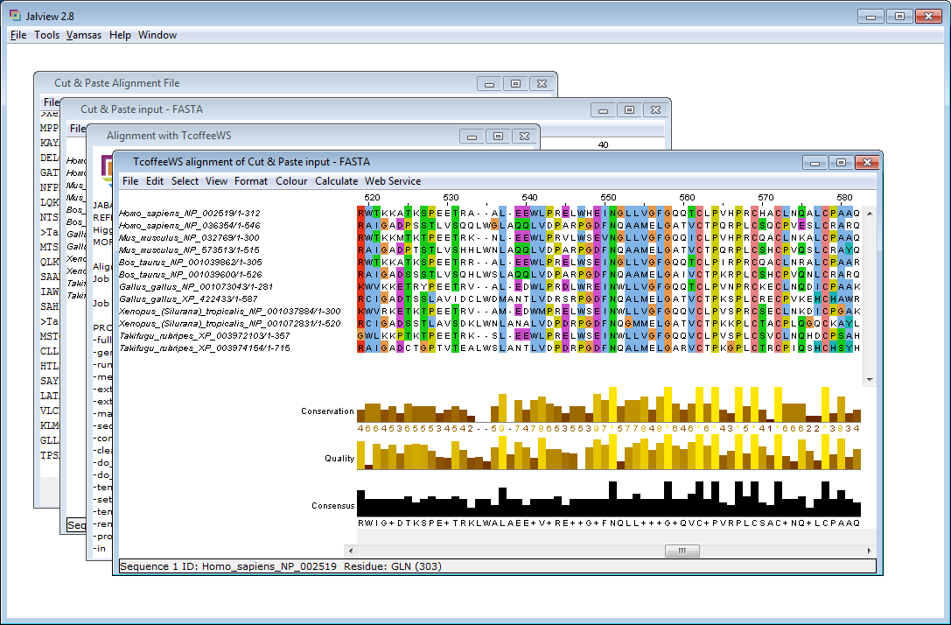

- In Jalview, generate a phylogenetic tree from the alignment of the twelve proteins (Choose “Calculate” → “Calculate Tree” → ”Average Distance Using BLOSUM62”). Click in the tree window to get different colours on the two clades in the tree (See below). Then, in the MSA windows, do “Calculate” → “Sort” → “By Tree Order” and choose sorting according to the tree you just generated.

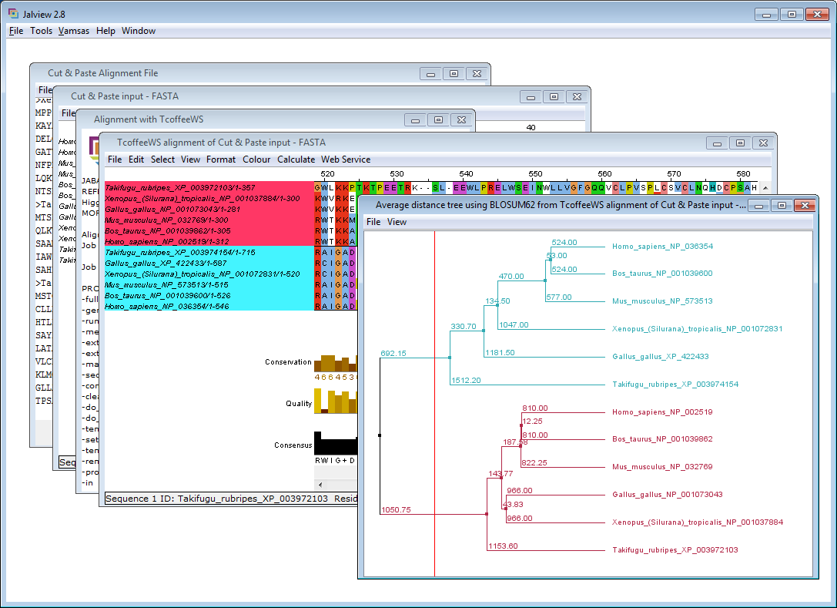
- Use the terms homologs, paralogs, and orthologs to describe the relationships between these proteins/genes.

NP_036354 is human MutY (with official gene name and symbol “mutY homolog” and MUTYH) while NP_002519 is human Nth (with official gene name and symbol “nth endonuclease III-like 1 (E. coli)” and NTHL1). All the other “blue” sequences/nodes in the figure above are orthologs of human MUTYH. They are unique genes/proteins due to a speciation event. Similarly, all the nodes in the “red” clade are orthologs of NTHL1. NTHL1 and MUTYH are paralogs, due to a gene duplication. All the sequences are homologs.

- We now change the names of the sequences a final time and put Nth in all the headers of the NTHL1 orthologs and MutY in all the headers of the MUTYH orthologs. Open the file 12verts_new.fasta in a text editor and change the headers so that all the Nth orthologs are named by their species and Nth (e.g. Homo_sapiens_Nth), while all MutY homologs are named with MutY (e.g. Homo_sapiens_MytY). Do this manually, or with a script. Save the new Fasta file as 12verts_final.fasta.
- Get the sequences from 12verts_final.fasta into Jalview and generate an MSA with the T-Coffee algorithm, as above. Also generate a phylogenetic tree and sort as above. Save the tree in PNG format, and import it into your report. Are all the clades as you would expect?
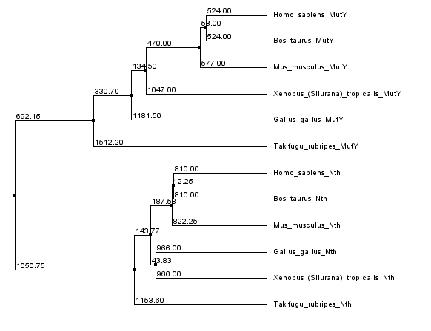
One would expect, in each of the two main clades, that the orthologs in human, mouse and cow were most similar, as they also are. Further out one would expect to encounter first chicken, then frog, and finally the fish orthologs. The fish clades are where they should be, but the frog/chicken is swapped (MutY) or in their own clade (Nth).

It is certainly not possible to make reliable phylogenetic species trees from just a single gene, but another problem here is that the phylogenetic tree building algorithms in Jalview are very simple. They can certainly not be used in a publication, for example!

This is a good review on how to make reliable trees: Z. Yang & B. Rannala, "Molecular phylogenetics: principles and practice", Nat. Rev. Genet. 13, 303 (2012).

- For the MSA, colour by percentage identity, turn off all annotations (remove the tick mark at “View” → “Show Annotations”), and use “Edit” → “Remove Left/Right” to trim the MSA and only keep the core part that is relatively conserved in all the sequences (roughly corresponding to human MutY residues 120 – 320). Turn on wrapping, and export the MSA as a PNG file. Import this alignment into PowerPoint or a similar program, and indicate the two sequence motifs. Copy the resulting figure into your report. Are both motifs fully conserved in all sequences?
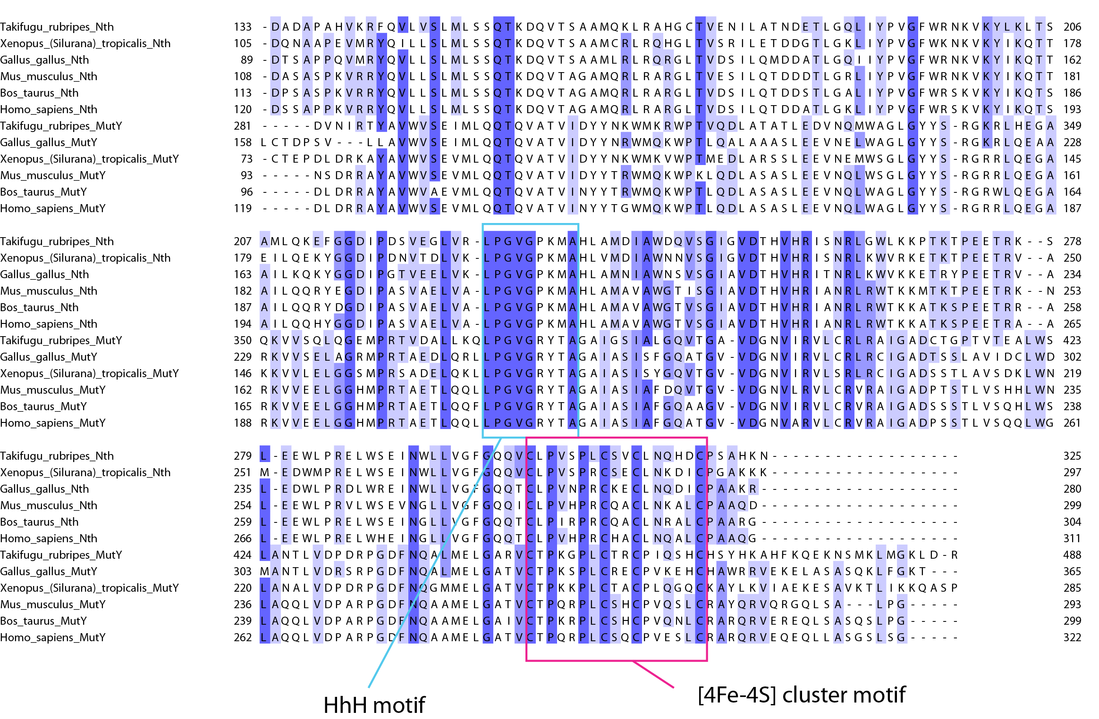
The 4 Cys residues of the [4Fe-4S] cluster motif are 100% conserved in all homologs. The motif LPGVGxxxA is conserved in all sequences where xxx is PKM or RYT in Nth and MutY, respectively.

- Select a chunk of the MSA between human MutY residues 270 and 307 containing the [4Fe-4S] cluster motif. Do this by left-clicking just above the MSA, next to “160” (See below), and pull to the right while holding down the mouse button. Select the “red region” below. Copy this segment by pressing <ctrl>-c, and paste this into a new window by pressing <ctrl>-<shift>-v. See below. It should look something like this!:
- Now let us make a sequence logo for this segment. Go to the following website, http://weblogo.berkeley.edu, and follow the link “create”. In Jalview, get the MSA for our [4Fe-4S] cluster motif segment in Fasta format by doing “File” → “Output to Textbox” → “FASTA”. Copy the Fasta format text into the window on the WebLogo website. Then press “Create Logo”. Put the logo in your report. Take a screen-shot, for example.

The logo gives a good illustration of which residues are conserved in this protein family and which are not.

- Using the sequence of E. coli Nth as query, perform an iterative protein PSI-BLAST search against the NCBI Reference protein sequence database (Refseq protein). Before doing the search, limit the search to vertebrate sequences, and change the “PSI-BLAST threshold” from the default value of 0.005 to 0.00005 (=5e-5). After convergence (or at least three iterations), reformat the results to include only human (Homo sapiens) sequences. From the results, select sequences corresponding to the four human homologs denoted Endonuclease III-like protein 1 (NTHL1) (312 aa), A/G-specific adenine DNA glycosylase isoform 1 (MUTYH) (546 aa), N-glycosylase/DNA lyase isoform 1a (OGG1) (345 aa) and methyl-CpG-binding domain protein 4 (MBD4) (580 aa). Give the sequences short names.

Make a multiple sequence alignment of the four sequences, using the MUSCLE program from JalView. Format the alignment as earlier. Then try the MAFFT and ClustalW programs. Import the three sequence alignments into your report.

MUSCLE:
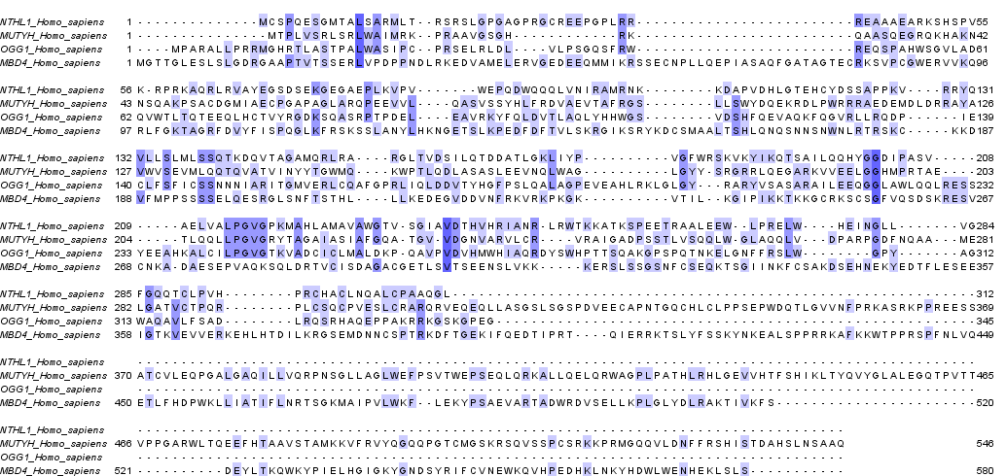

MAFFT:
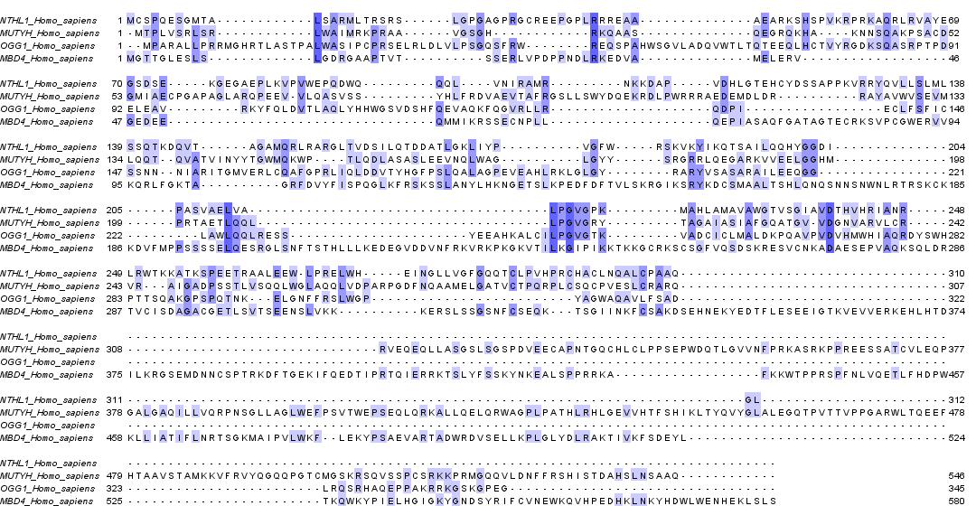

CLUSTAL:
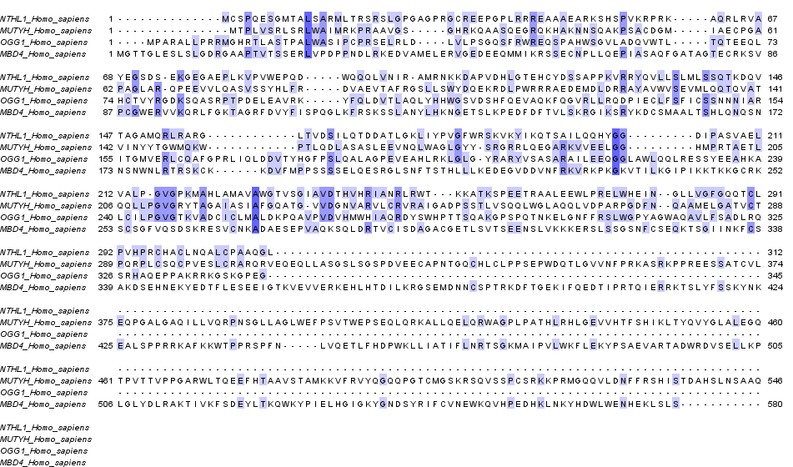

- Are the HhH motif and the [4Fe–4S] cluster motif present in all four sequences? Note that the first 400 residues in the N-terminal of MBD4 are unrelated to the other proteins, and any similarity to that N-terminal part of the MBD4 protein is completely random.

The HhH motif is well conserved in NTHL1, MUTYH and OGG1. However, ClustalW does not align the initial L and P correctly for NTHL1.

The [4Fe-4S] cluster motif is fully conserved in NTHL1 and MUTYH, but not nicely aligned above due to the other two sequences that are lacking the motif. Actually, there is no [4Fe-4S] cluster in OGG1 or MBD4. Hence, there is no need to conserve, during evolution, the Cys residues that are complexing the iron-sulphur cluster in the other homologs.

MBD4 is also aligned to both these motifs with all three programs, but to the wrong part of MBD4.

- Judging from the proper alignment of residues in the two motifs, which of the programs has produced the worst alignment?

The Clustal W program seemes to produce the worst alignment, as the HhH motif was not well aligned in NTHL1.

- Finally, make MUSCLE and MAFFT alignments where you also include the bacterial and vertebrate Nth and MutY sequences that we worked with earlier. Do not duplicate the human Nth and MutY. Format the alignment as earlier, but sort “by ID”. Include the alignments in your report, but crop the images so that only the region “core region” with the HhH motif is shown. Are any of the programs able to correctly align the HhH motif when all sequences are included? Which important lesson can we learn from this? Which program performed best?

MUSCLE:
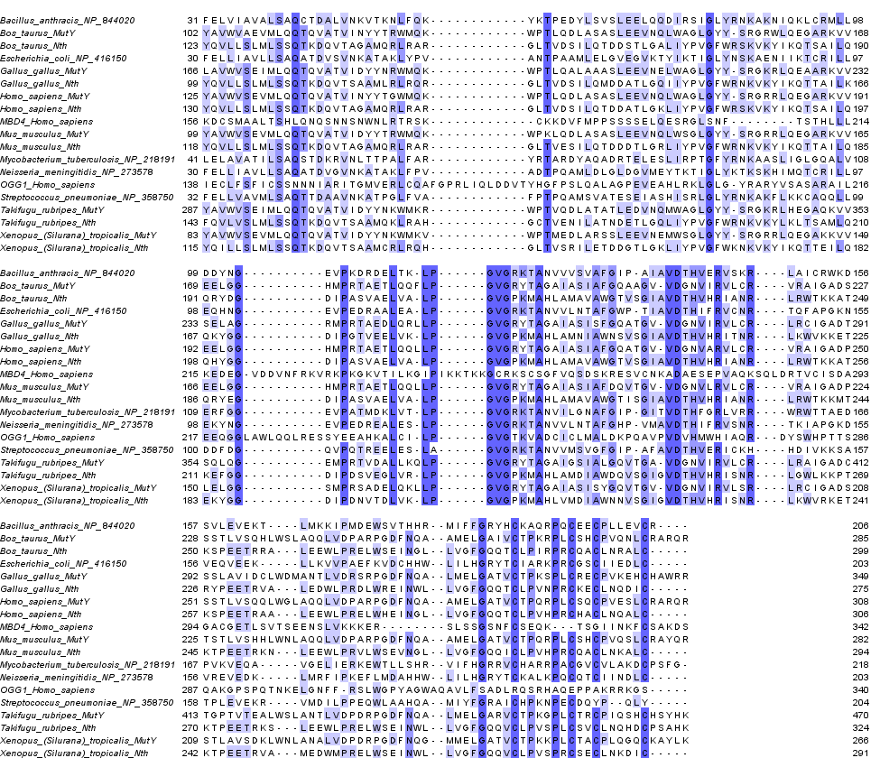

MAFFT:
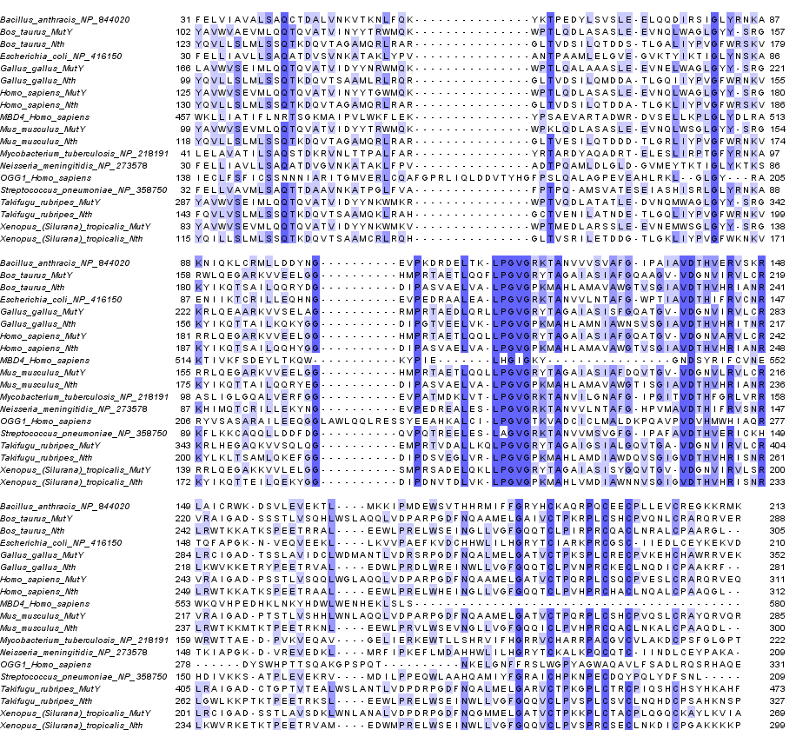

MAFFT was able to correctly align the HhH motif of MBD4 with all the others when all sequences are included. MUSCLE did not. MAFFT performed best, but this is no general rule. MUSCLE and T-Coffee are also excellent MSA programs.

Important: Very often, you get a better alignment of two, or a few sequences, if you align these sequences together with many homologs!

- If you have more time, experiment and modify the script for example to
  - Use H_sapiens, M_musculus, and so on in the headers
  - Automatically generate 12verts_final.fasta from 12verts.fasta
  - Or download a few hundred Nth vertebrate homologs from the BLAST results and test the script on this bigger data set. If necessary, modify the script to be more robust

APPENDIX 1:

Bacterial Nth homologs, original sequences

>gi|16129591|ref|NP_416150.1| DNA glycosylase and apyrimidinic (AP) lyase (endonuclease III) [Escherichia coli str. K-12 substr. MG1655]
MNKAKRLEILTRLRENNPHPTTELNFSSPFELLIAVLLSAQATDVSVNKATAKLYPVANTPAAMLELGVE
GVKTYIKTIGLYNSKAENIIKTCRILLEQHNGEVPEDRAALEALPGVGRKTANVVLNTAFGWPTIAVDTH
IFRVCNRTQFAPGKNVEQVEEKLLKVVPAEFKVDCHHWLILHGRYTCIARKPRCGSCIIEDLCEYKEKVD
I
>gi|57117142|ref|NP_218191.2| Probable endonuclease III Nth (DNA-(apurinic or apyrimidinic site)lyase) (AP lyase) (AP endonuclease class I) (endodeoxyribonuclease (apurinic or apyrimidinic)) (deoxyribonuclease (apurinic or apyrimidinic)) [Mycobacterium tuberculosis H37Rv]
MPGRWSAETRLALVRRARRMNRALAQAFPHVYCELDFTTPLELAVATILSAQSTDKRVNLTTPALFARYR
TARDYAQADRTELESLIRPTGFYRNKAASLIGLGQALVERFGGEVPATMDKLVTLPGVGRKTANVILGNA
FGIPGITVDTHFGRLVRRWRWTTAEDPVKVEQAVGELIERKEWTLLSHRVIFHGRRVCHARRPACGVCVL
AKDCPSFGLGPTEPLLAAPLVQGPETDHLLALAGL
>gi|30261643|ref|NP_844020.1| endonuclease III [Bacillus anthracis str. Ames]
MLNKTQIRYCLDTMADMYPEAHCELIHDNPFELVIAVALSAQCTDALVNKVTKNLFQKYKTPEDYLSVSL
EELQQDIRSIGLYRNKAKNIQKLCRMLLDDYNGEVPKDRDELTKLPGVGRKTANVVVSVAFGIPAIAVDT
HVERVSKRLAICRWKDSVLEVEKTLMKKIPMDEWSVTHHRMIFFGRYHCKAQRPQCEECPLLEVCREGKK
RMKGK
>gi|15676439|ref|NP_273578.1| endonuclease III [Neisseria meningitidis MC58]
MNRHIRQEIFERFRAANPHPTTELNFNSPFELLIAVLLSAQATDVGVNKATAKLFPVADTPQAMLDLGLD
GVMEYTKTIGLYKTKSKHIMQTCRILLEKYNGEVPEDREALESLPGVGRKTANVVLNTAFGHPVMAVDTH
IFRVSNRTKIAPGKDVREVEDKLMRFIPKEFLMDAHHWLILHGRYTCKALKPQCQTCIINDLCEYPAKA
>gi|15903200|ref|NP_358750.1| endonuclease III [Streptococcus pneumoniae R6]
MVLSKKRARKVLEEIIALFPDAKPSLDFTNHFELLVAVMLSAQTTDAAVNKATPGLFVAFPTPQAMSVAT
ESEIASHISRLGLYRNKAKFLKKCAQQLLDDFDGQVPQTREELESLAGVGRKTANVVMSVGFGIPAFAVD
THVERICKHHDIVKKSATPLEVEKRVMDILPPEQWLAAHQAMIYFGRAICHPKNPECDQYPQLYDFSNL

APPENDIX 2:

Bacterial Nth homologs, modified headers

>Escherichia_coli_NP_416150
MNKAKRLEILTRLRENNPHPTTELNFSSPFELLIAVLLSAQATDVSVNKATAKLYPVANTPAAMLELGVE
GVKTYIKTIGLYNSKAENIIKTCRILLEQHNGEVPEDRAALEALPGVGRKTANVVLNTAFGWPTIAVDTH
IFRVCNRTQFAPGKNVEQVEEKLLKVVPAEFKVDCHHWLILHGRYTCIARKPRCGSCIIEDLCEYKEKVD
I
>Mycobacterium_tuberculosis_NP_218191
MPGRWSAETRLALVRRARRMNRALAQAFPHVYCELDFTTPLELAVATILSAQSTDKRVNLTTPALFARYR
TARDYAQADRTELESLIRPTGFYRNKAASLIGLGQALVERFGGEVPATMDKLVTLPGVGRKTANVILGNA
FGIPGITVDTHFGRLVRRWRWTTAEDPVKVEQAVGELIERKEWTLLSHRVIFHGRRVCHARRPACGVCVL
AKDCPSFGLGPTEPLLAAPLVQGPETDHLLALAGL
>Bacillus_anthracis_NP_844020
MLNKTQIRYCLDTMADMYPEAHCELIHDNPFELVIAVALSAQCTDALVNKVTKNLFQKYKTPEDYLSVSL
EELQQDIRSIGLYRNKAKNIQKLCRMLLDDYNGEVPKDRDELTKLPGVGRKTANVVVSVAFGIPAIAVDT
HVERVSKRLAICRWKDSVLEVEKTLMKKIPMDEWSVTHHRMIFFGRYHCKAQRPQCEECPLLEVCREGKK
RMKGK
>Neisseria_meningitidis_NP_273578
MNRHIRQEIFERFRAANPHPTTELNFNSPFELLIAVLLSAQATDVGVNKATAKLFPVADTPQAMLDLGLD
GVMEYTKTIGLYKTKSKHIMQTCRILLEKYNGEVPEDREALESLPGVGRKTANVVLNTAFGHPVMAVDTH
IFRVSNRTKIAPGKDVREVEDKLMRFIPKEFLMDAHHWLILHGRYTCKALKPQCQTCIINDLCEYPAKA
>Streptococcus_pneumoniae_NP_358750
MVLSKKRARKVLEEIIALFPDAKPSLDFTNHFELLVAVMLSAQTTDAAVNKATPGLFVAFPTPQAMSVAT
ESEIASHISRLGLYRNKAKFLKKCAQQLLDDFDGQVPQTREELESLAGVGRKTANVVMSVGFGIPAFAVD
THVERICKHHDIVKKSATPLEVEKRVMDILPPEQWLAAHQAMIYFGRAICHPKNPECDQYPQLYDFSNL

APPENDIX 3:

12 vertebrate homologs, original sequences

>gi|4505471|ref|NP_002519.1| endonuclease III-like protein 1 [Homo sapiens]
MCSPQESGMTALSARMLTRSRSLGPGAGPRGCREEPGPLRRREAAAEARKSHSPVKRPRKAQRLRVAYEGSDSEKGEGAE
PLKVPVWEPQDWQQQLVNIRAMRNKKDAPVDHLGTEHCYDSSAPPKVRRYQVLLSLMLSSQTKDQVTAGAMQRLRARGLT
VDSILQTDDATLGKLIYPVGFWRSKVKYIKQTSAILQQHYGGDIPASVAELVALPGVGPKMAHLAMAVAWGTVSGIAVDT
HVHRIANRLRWTKKATKSPEETRAALEEWLPRELWHEINGLLVGFGQQTCLPVHPRCHACLNQALCPAAQGL
>gi|6912520|ref|NP_036354.1| A/G-specific adenine DNA glycosylase isoform 1 [Homo sapiens]
MTPLVSRLSRLWAIMRKPRAAVGSGHRKQAASQEGRQKHAKNNSQAKPSACDGMIAECPGAPAGLARQPEEVVLQASVSS
YHLFRDVAEVTAFRGSLLSWYDQEKRDLPWRRRAEDEMDLDRRAYAVWVSEVMLQQTQVATVINYYTGWMQKWPTLQDLA
SASLEEVNQLWAGLGYYSRGRRLQEGARKVVEELGGHMPRTAETLQQLLPGVGRYTAGAIASIAFGQATGVVDGNVARVL
CRVRAIGADPSSTLVSQQLWGLAQQLVDPARPGDFNQAAMELGATVCTPQRPLCSQCPVESLCRARQRVEQEQLLASGSL
SGSPDVEECAPNTGQCHLCLPPSEPWDQTLGVVNFPRKASRKPPREESSATCVLEQPGALGAQILLVQRPNSGLLAGLWE
FPSVTWEPSEQLQRKALLQELQRWAGPLPATHLRHLGEVVHTFSHIKLTYQVYGLALEGQTPVTTVPPGARWLTQEEFHT
AAVSTAMKKVFRVYQGQQPGTCMGSKRSQVSSPCSRKKPRMGQQVLDNFFRSHISTDAHSLNSAAQ
>gi|227908769|ref|NP_032769.2| endonuclease III-like protein 1 [Mus musculus]
MNSGVRMVTRSRSRATRIASEGCREELAPREAAAEGRKSHRPVRHPRRTQKTHVAYEAANGEEGEDAEPLKVPVWEPQNW
QQQLANIRIMRSKKDAPVDQLGAEHCYDASASPKVRRYQVLLSLMLSSQTKDQVTAGAMQRLRARGLTVESILQTDDDTL
GRLIYPVGFWRNKVKYIKQTTAILQQRYEGDIPASVAELVALPGVGPKMAHLAMAVAWGTISGIAVDTHVHRIANRLRWT
KKMTKTPEETRKNLEEWLPRVLWSEVNGLLVGFGQQICLPVHPRCQACLNKALCPAAQDL
>gi|227330621|ref|NP_573513.2| A/G-specific adenine DNA glycosylase [Mus musculus] MKKLQASVRSHKKQPANHKRRRTRALSSSQAKPSSLDGLAKQKREELLQASVSPYHLFSDVADVTAFRSNLLSWYDQEKR
DLPWRNLAKEEANSDRRAYAVWVSEVMLQQTQVATVIDYYTRWMQKWPKLQDLASASLEEVNQLWSGLGYYSRGRRLQEG
ARKVVEELGGHMPRTAETLQQLLPGVGRYTAGAIASIAFDQVTGVVDGNVLRVLCRVRAIGADPTSTLVSHHLWNLAQQL
VDPARPGDFNQAAMELGATVCTPQRPLCSHCPVQSLCRAYQRVQRGQLSALPGRPDIEECALNTRQCQLCLTSSSPWDPS
MGVANFPRKASRRPPREEYSATCVVEQPGAIGGPLVLLVQRPDSGLLAGLWEFPSVTLEPSEQHQHKALLQELQRWCGPL
PAIRLQHLGEVIHIFSHIKLTYQVYSLALDQAPASTAPPGARWLTWEEFCNAAVSTAMKKVFRMYEDHRQGTRKGSKRSQ
VCPPSSRKKPSLGQQVLDTFFQRHIPTDKPNSTTQ
>gi|114051958|ref|NP_001039862.1| endonuclease III-like protein 1 [Bos taurus]
MNAAGVRMVVTRARSRGTGASLRRRGEKAAPLRSGEAAAEERKSYSPVKRRRKAQRLSVAYEASEGEGGEGAEHLQAPSW
QPQDWRQQLDNIRTMRSGKDAPVDQLGAEHCFDPSASPKVRRYQVLLSLMLSSQTKDQVTAGAMQRLRARGLTVDSILQT
DDSTLGALIYPVGFWRSKVKYIKQTSAILQQRYDGDIPASVAELVALPGVGPKMAHLAMAVAWGTVSGIAVDTHVHRIAN
RLRWTKKATKSPEETRRALEEWLPRELWSEINGLLVGFGQQTCLPIRPRCQACLNRALCPAARGL
>gi|281485563|ref|NP_001039600.2| A/G-specific adenine DNA glycosylase [Bos taurus]
MKKSRAAVGNRSGRRKQASSQEGKEKCAFGSSQAKPSAPSAGPARQQKALLQASVSPYHLFRDVAEVTALQESLLDWYDR
KKRDLPWRRLVEDEVDLDRRAYAVWVAEVMLQQTQVATVINYYTRWMQKWPTLQDLASASLEEVNQLWAGLGYYSRGRWL
QEGARKVVEELGGHMPRTAETLQQFLPGVGRYTAGAIASIAFGQAAGVVDGNVIRVLCRVRAIGADSSSTLVSQHLWSLA
QQLVDPARPGDFNQAAMELGAIVCTPKRPLCSHCPVQNLCRARQRVEREQLSASQSLPGNCDVEECAPNTGQCPLCAPPT
EPWDQTLGVTNFPRKASRKPPREECSAICVLEQPKALGGAHILLVQRPNSGLLAGLWEFPSVSVNAEASGQHQRAALLQE
LQSWVGPLPDTRLQHLGQVVHTFSHIKMTYQVYSLALEEHTPVTIVPPGARWLTREDFHTAAVSTAMKKVFRMYEGQQPG
TCKGSKRSQVATLSKRKKPSPGQQVLESFFWPHVPTDAPSLNTAAQ
>gi|118601744|ref|NP_001073043.1| endonuclease III-like protein 1 [Gallus gallus]
MCAAAPRGGGRAARRLGAATAGSRVPSAAPRYSRRTRRVPIAYEAEPKPESPGPKWEPENWQQQLERIREMRRHRDAPVD
EMGVDKCYDTSAPPQVMRYQVLLSLMLSSQTKDQVTSAAMLRLRQRGLTVDSILQMDDATLGQIIYPVGFWRNKVKYIKQ
TTAILKQKYGGDIPGTVEELVKLPGVGPKMAHLAMNIAWNSVSGIAVDTHVHRITNRLKWVKKETRYPEETRVALEDWLP
RDLWREINWLLVGFGQQTCLPVNPRCKECLNQDICPAAKRF
>gi|513197809|ref|XP_422433.3| PREDICTED: A/G-specific adenine DNA glycosylase isoform X5 [Gallus gallus]
MGGAAVRARRSVKVRAGGEHVGPGLGSPAIALRTHRRCCDPTPVPVSRQGLPLDHMHCISSVTPSRSMPYVAACSPGMTK
AGGTFPGGRWLQLSWMLTGGRMQLLGLLVASERQVWARERSCGDEDGEEGCWVGFCCSSWNQQHGDRGACCEKWHWHLCT
DPSVLLAVWVSEIMLQQTQVATVIDYYNRWMQKWPTLQALAAASLEEVNELWAGLGYYSRGKRLQEAARKVVSELAGRMP
RTAEDLQRLLPGVGRYTAGAIASISFGQATGVVDGNVIRVLCRLRCIGADTSSLAVIDCLWDMANTLVDRSRPGDFNQAL
MELGATVCTPKSPLCRECPVKEHCHAWRRVEKELASASQKLFGKTTLVPDVEDCGPGGCPLCLPAAEPWDSSLGVTNFPR
KAAKKQPRVEWTATCVLERRGRLGAPEYLIVQRPSSGLLAGLWEFPSLPLAPGLQEEQQKEVLADHLRAWTRQPVQTQSL
CFIGEVVHIFSHIHQTYVVYSLCLDGDVALDAASSPSRWVTEEEFRASAVSTAMKKVLKARETQRGVQSGRAKGSKRKRE
SKLGAAGSTPTGMQLSLRAFLRAQPPP
>gi|113205550|ref|NP_001037884.1| nth endonuclease III-like 1 [Xenopus (Silurana) tropicalis]
MSGSLRPLGRRGRRGVLKAVGGKDQQDGTSKGQVIDDSEDEKPSSPKERSKRRVSVEYEQAASETVAKRPKWQPKNWAQH
LENIRQMRSRRDAPVDQMGAEKCYDQNAAPEVMRYQILLSLMLSSQTKDQVTSAAMCRLRQHGLTVSRILETDDGTLGKL
IYPVGFWKNKVKYIKQTTEILQEKYGGDIPDNVTDLVKLPGVGPKMAHLVMDIAWNNVSGIGVDTHVHRISNRLKWVRKE
TKTPEETRVAMEDWMPRELWSEINWLLVGFGQQVCLPVSPRCSECLNKDICPGAKKKKPR
>gi|118403607|ref|NP_001072831.1| mutY homolog [Xenopus (Silurana) tropicalis]
MPPPRTKTSLGRSAAASGKRKSPKQAFPKREEHVLQSSIYHSFTSQETEIIRDKLLAWYDKSKRDLPWRTMACTEPDLDR
KAYAVWVSEVMLQQTQVATVIDYYNKWMKVWPTMEDLARSSLEEVNEMWSGLGYYSRGRRLQEGAKKVVLELGGSMPRSA
DELQKLLPGVGRYTAGAIASISYGQVTGVVDGNVIRVLSRLRCIGADSSTLAVSDKLWNLANALVDPDRPGDFNQGMMEL
GATVCTPKKPLCTACPLQGQCKAYLKVIAEKESAVKTLIKKQASPIAKDVGDIEDCDLGPGLCALCVPTSDPWDSSLGVA
NFPRKSAKKPSRMEQTAICVWEKCGDHGELEYLIVQRPSSGLLAGLWEFPSILLDEKFTEQNRQHSLLGLLQDLSGHAVP
LQKLQYKGEVVHIFSHIHQTYVVYFLSLNTTENCSVKTEETERPLTRWVTKKEFLNSAVPTAMKKIMKLCESHGSSCTAV
NTSKKRKGDLAKVQLPSGRIKTEKGKQQSIQSFFKLATEK
>gi|410917257|ref|XP_003972103.1| PREDICTED: endonuclease III-like protein 1-like [Takifugu rubripes]
MTSHYFAQSRSVVTRRGAQNAAHKPATSLKSKLTIQPEKDDLVSSSAGVKLEEEEAKISGNALKPETDAPTLSSHSRRRR
QLKVEYDKDGSMPQLKTEPWEPPRWKTQLENIRAMRSGRDAPVDNMGADKCHDADAPAHVKRFQVLVSLMLSSQTKDQVT
SAAMQKLRAHGCTVENILATNDETLGQLIYPVGFWRNKVKYLKLTSAMLQKEFGGDIPDSVEGLVRLPGVGPKMAHLAMD
IAWDQVSGIGVDTHVHRISNRLGWLKKPTKTPEETRKSLEEWLPRELWSEINWLLVGFGQQVCLPVSPLCSVCLNQHDCP
SAHKNSPVRRPKFLERSPWIKSPRLFITPGANTFLIR
>gi|410921366|ref|XP_003974154.1| PREDICTED: A/G-specific adenine DNA glycosylase-like [Takifugu rubripes]
MSTQGEPVQVGKVLSFLREWDRGDRSARGRMLSSFLGRSAGRTQGELEYLGEFVGHGGVVTLLEVLTQPQSNEETKAEAL
CLLLAISDAGRKYKELICQSCGAMAAAECLTHSGTGETQESAWMLLESLSHGNPKYEGEIYKGLIGHLTCTSAKAQQFVL
HTLHTLQSKMEIAHHSIVEPLLGVLTSLHPDVQSEVARLIFELRRYDVRPMLLRALCGLGLNVARAPTYPEEESSHASSP
SAYHFFHDAADVALLRSRLLAWYDQEKRELPWRTLALTEPDVNIRTYAVWVSEIMLQQTQVATVIDYYNKWMKRWPTVQD
LATATLEDVNQMWAGLGYYSRGKRLHEGAQKVVSQLQGEMPRTVDALLKQLPGVGRYTAGAIGSIALGQVTGAVDGNVIR
VLCRLRAIGADCTGPTVTEALWSLANTLVDPDRPGDFNQALMELGARVCTPKGPLCTRCPIQSHCHSYHKAHFKQEKNSM
KLMGKLDRKSSALPDIEDCLSSGTCTLCLSEPWDDELGVQNFPRKPAKKPPRAERCLTCVVIRQGEGGEHEFLLTQRPSK
GLLAGLWEFPCINHEEKNAVEEKKVLCAEINRILGTSLTHGLLQYVGEVVHIFSHIHQTYVVHTLRLKDAVSQSENMQWL
TPSALQEAAVSTGVKKIMKLCNSALGQQGAPDGEEKRPKKDRKGQITKRPRLSGANSRSRQLSLSSFFQTVKQDC

APPENDIX 4:

12 vertebrate homologs, modified headers

>Homo_sapiens_NP_002519
MCSPQESGMTALSARMLTRSRSLGPGAGPRGCREEPGPLRRREAAAEARKSHSPVKRPRKAQRLRVAYEGSDSEKGEGAE
PLKVPVWEPQDWQQQLVNIRAMRNKKDAPVDHLGTEHCYDSSAPPKVRRYQVLLSLMLSSQTKDQVTAGAMQRLRARGLT
VDSILQTDDATLGKLIYPVGFWRSKVKYIKQTSAILQQHYGGDIPASVAELVALPGVGPKMAHLAMAVAWGTVSGIAVDT
HVHRIANRLRWTKKATKSPEETRAALEEWLPRELWHEINGLLVGFGQQTCLPVHPRCHACLNQALCPAAQGL
>Homo_sapiens_NP_036354
MTPLVSRLSRLWAIMRKPRAAVGSGHRKQAASQEGRQKHAKNNSQAKPSACDGMIAECPGAPAGLARQPEEVVLQASVSS
YHLFRDVAEVTAFRGSLLSWYDQEKRDLPWRRRAEDEMDLDRRAYAVWVSEVMLQQTQVATVINYYTGWMQKWPTLQDLA
SASLEEVNQLWAGLGYYSRGRRLQEGARKVVEELGGHMPRTAETLQQLLPGVGRYTAGAIASIAFGQATGVVDGNVARVL
CRVRAIGADPSSTLVSQQLWGLAQQLVDPARPGDFNQAAMELGATVCTPQRPLCSQCPVESLCRARQRVEQEQLLASGSL
SGSPDVEECAPNTGQCHLCLPPSEPWDQTLGVVNFPRKASRKPPREESSATCVLEQPGALGAQILLVQRPNSGLLAGLWE
FPSVTWEPSEQLQRKALLQELQRWAGPLPATHLRHLGEVVHTFSHIKLTYQVYGLALEGQTPVTTVPPGARWLTQEEFHT
AAVSTAMKKVFRVYQGQQPGTCMGSKRSQVSSPCSRKKPRMGQQVLDNFFRSHISTDAHSLNSAAQ
>Mus_musculus_NP_032769
MNSGVRMVTRSRSRATRIASEGCREELAPREAAAEGRKSHRPVRHPRRTQKTHVAYEAANGEEGEDAEPLKVPVWEPQNW
QQQLANIRIMRSKKDAPVDQLGAEHCYDASASPKVRRYQVLLSLMLSSQTKDQVTAGAMQRLRARGLTVESILQTDDDTL
GRLIYPVGFWRNKVKYIKQTTAILQQRYEGDIPASVAELVALPGVGPKMAHLAMAVAWGTISGIAVDTHVHRIANRLRWT
KKMTKTPEETRKNLEEWLPRVLWSEVNGLLVGFGQQICLPVHPRCQACLNKALCPAAQDL
>Mus_musculus_NP_573513
MKKLQASVRSHKKQPANHKRRRTRALSSSQAKPSSLDGLAKQKREELLQASVSPYHLFSDVADVTAFRSNLLSWYDQEKR
DLPWRNLAKEEANSDRRAYAVWVSEVMLQQTQVATVIDYYTRWMQKWPKLQDLASASLEEVNQLWSGLGYYSRGRRLQEG
ARKVVEELGGHMPRTAETLQQLLPGVGRYTAGAIASIAFDQVTGVVDGNVLRVLCRVRAIGADPTSTLVSHHLWNLAQQL
VDPARPGDFNQAAMELGATVCTPQRPLCSHCPVQSLCRAYQRVQRGQLSALPGRPDIEECALNTRQCQLCLTSSSPWDPS
MGVANFPRKASRRPPREEYSATCVVEQPGAIGGPLVLLVQRPDSGLLAGLWEFPSVTLEPSEQHQHKALLQELQRWCGPL
PAIRLQHLGEVIHIFSHIKLTYQVYSLALDQAPASTAPPGARWLTWEEFCNAAVSTAMKKVFRMYEDHRQGTRKGSKRSQ
VCPPSSRKKPSLGQQVLDTFFQRHIPTDKPNSTTQ
>Bos_taurus_NP_001039862
MNAAGVRMVVTRARSRGTGASLRRRGEKAAPLRSGEAAAEERKSYSPVKRRRKAQRLSVAYEASEGEGGEGAEHLQAPSW
QPQDWRQQLDNIRTMRSGKDAPVDQLGAEHCFDPSASPKVRRYQVLLSLMLSSQTKDQVTAGAMQRLRARGLTVDSILQT
DDSTLGALIYPVGFWRSKVKYIKQTSAILQQRYDGDIPASVAELVALPGVGPKMAHLAMAVAWGTVSGIAVDTHVHRIAN
RLRWTKKATKSPEETRRALEEWLPRELWSEINGLLVGFGQQTCLPIRPRCQACLNRALCPAARGL
>Bos_taurus_NP_001039600
MKKSRAAVGNRSGRRKQASSQEGKEKCAFGSSQAKPSAPSAGPARQQKALLQASVSPYHLFRDVAEVTALQESLLDWYDR
KKRDLPWRRLVEDEVDLDRRAYAVWVAEVMLQQTQVATVINYYTRWMQKWPTLQDLASASLEEVNQLWAGLGYYSRGRWL
QEGARKVVEELGGHMPRTAETLQQFLPGVGRYTAGAIASIAFGQAAGVVDGNVIRVLCRVRAIGADSSSTLVSQHLWSLA
QQLVDPARPGDFNQAAMELGAIVCTPKRPLCSHCPVQNLCRARQRVEREQLSASQSLPGNCDVEECAPNTGQCPLCAPPT
EPWDQTLGVTNFPRKASRKPPREECSAICVLEQPKALGGAHILLVQRPNSGLLAGLWEFPSVSVNAEASGQHQRAALLQE
LQSWVGPLPDTRLQHLGQVVHTFSHIKMTYQVYSLALEEHTPVTIVPPGARWLTREDFHTAAVSTAMKKVFRMYEGQQPG
TCKGSKRSQVATLSKRKKPSPGQQVLESFFWPHVPTDAPSLNTAAQ
>Gallus_gallus_NP_001073043
MCAAAPRGGGRAARRLGAATAGSRVPSAAPRYSRRTRRVPIAYEAEPKPESPGPKWEPENWQQQLERIREMRRHRDAPVD
EMGVDKCYDTSAPPQVMRYQVLLSLMLSSQTKDQVTSAAMLRLRQRGLTVDSILQMDDATLGQIIYPVGFWRNKVKYIKQ
TTAILKQKYGGDIPGTVEELVKLPGVGPKMAHLAMNIAWNSVSGIAVDTHVHRITNRLKWVKKETRYPEETRVALEDWLP
RDLWREINWLLVGFGQQTCLPVNPRCKECLNQDICPAAKRF
>Gallus_gallus_XP_422433
MGGAAVRARRSVKVRAGGEHVGPGLGSPAIALRTHRRCCDPTPVPVSRQGLPLDHMHCISSVTPSRSMPYVAACSPGMTK
AGGTFPGGRWLQLSWMLTGGRMQLLGLLVASERQVWARERSCGDEDGEEGCWVGFCCSSWNQQHGDRGACCEKWHWHLCT
DPSVLLAVWVSEIMLQQTQVATVIDYYNRWMQKWPTLQALAAASLEEVNELWAGLGYYSRGKRLQEAARKVVSELAGRMP
RTAEDLQRLLPGVGRYTAGAIASISFGQATGVVDGNVIRVLCRLRCIGADTSSLAVIDCLWDMANTLVDRSRPGDFNQAL
MELGATVCTPKSPLCRECPVKEHCHAWRRVEKELASASQKLFGKTTLVPDVEDCGPGGCPLCLPAAEPWDSSLGVTNFPR
KAAKKQPRVEWTATCVLERRGRLGAPEYLIVQRPSSGLLAGLWEFPSLPLAPGLQEEQQKEVLADHLRAWTRQPVQTQSL
CFIGEVVHIFSHIHQTYVVYSLCLDGDVALDAASSPSRWVTEEEFRASAVSTAMKKVLKARETQRGVQSGRAKGSKRKRE
SKLGAAGSTPTGMQLSLRAFLRAQPPP
>Xenopus_(Silurana)_tropicalis_NP_001037884
MSGSLRPLGRRGRRGVLKAVGGKDQQDGTSKGQVIDDSEDEKPSSPKERSKRRVSVEYEQAASETVAKRPKWQPKNWAQH
LENIRQMRSRRDAPVDQMGAEKCYDQNAAPEVMRYQILLSLMLSSQTKDQVTSAAMCRLRQHGLTVSRILETDDGTLGKL
IYPVGFWKNKVKYIKQTTEILQEKYGGDIPDNVTDLVKLPGVGPKMAHLVMDIAWNNVSGIGVDTHVHRISNRLKWVRKE
TKTPEETRVAMEDWMPRELWSEINWLLVGFGQQVCLPVSPRCSECLNKDICPGAKKKKPR
>Xenopus_(Silurana)_tropicalis_NP_001072831
MPPPRTKTSLGRSAAASGKRKSPKQAFPKREEHVLQSSIYHSFTSQETEIIRDKLLAWYDKSKRDLPWRTMACTEPDLDR
KAYAVWVSEVMLQQTQVATVIDYYNKWMKVWPTMEDLARSSLEEVNEMWSGLGYYSRGRRLQEGAKKVVLELGGSMPRSA
DELQKLLPGVGRYTAGAIASISYGQVTGVVDGNVIRVLSRLRCIGADSSTLAVSDKLWNLANALVDPDRPGDFNQGMMEL
GATVCTPKKPLCTACPLQGQCKAYLKVIAEKESAVKTLIKKQASPIAKDVGDIEDCDLGPGLCALCVPTSDPWDSSLGVA
NFPRKSAKKPSRMEQTAICVWEKCGDHGELEYLIVQRPSSGLLAGLWEFPSILLDEKFTEQNRQHSLLGLLQDLSGHAVP
LQKLQYKGEVVHIFSHIHQTYVVYFLSLNTTENCSVKTEETERPLTRWVTKKEFLNSAVPTAMKKIMKLCESHGSSCTAV
NTSKKRKGDLAKVQLPSGRIKTEKGKQQSIQSFFKLATEK
>Takifugu_rubripes_XP_003972103
MTSHYFAQSRSVVTRRGAQNAAHKPATSLKSKLTIQPEKDDLVSSSAGVKLEEEEAKISGNALKPETDAPTLSSHSRRRR
QLKVEYDKDGSMPQLKTEPWEPPRWKTQLENIRAMRSGRDAPVDNMGADKCHDADAPAHVKRFQVLVSLMLSSQTKDQVT
SAAMQKLRAHGCTVENILATNDETLGQLIYPVGFWRNKVKYLKLTSAMLQKEFGGDIPDSVEGLVRLPGVGPKMAHLAMD
IAWDQVSGIGVDTHVHRISNRLGWLKKPTKTPEETRKSLEEWLPRELWSEINWLLVGFGQQVCLPVSPLCSVCLNQHDCP
SAHKNSPVRRPKFLERSPWIKSPRLFITPGANTFLIR
>Takifugu_rubripes_XP_003974154
MSTQGEPVQVGKVLSFLREWDRGDRSARGRMLSSFLGRSAGRTQGELEYLGEFVGHGGVVTLLEVLTQPQSNEETKAEAL
CLLLAISDAGRKYKELICQSCGAMAAAECLTHSGTGETQESAWMLLESLSHGNPKYEGEIYKGLIGHLTCTSAKAQQFVL
HTLHTLQSKMEIAHHSIVEPLLGVLTSLHPDVQSEVARLIFELRRYDVRPMLLRALCGLGLNVARAPTYPEEESSHASSP
SAYHFFHDAADVALLRSRLLAWYDQEKRELPWRTLALTEPDVNIRTYAVWVSEIMLQQTQVATVIDYYNKWMKRWPTVQD
LATATLEDVNQMWAGLGYYSRGKRLHEGAQKVVSQLQGEMPRTVDALLKQLPGVGRYTAGAIGSIALGQVTGAVDGNVIR
VLCRLRAIGADCTGPTVTEALWSLANTLVDPDRPGDFNQALMELGARVCTPKGPLCTRCPIQSHCHSYHKAHFKQEKNSM
KLMGKLDRKSSALPDIEDCLSSGTCTLCLSEPWDDELGVQNFPRKPAKKPPRAERCLTCVVIRQGEGGEHEFLLTQRPSK
GLLAGLWEFPCINHEEKNAVEEKKVLCAEINRILGTSLTHGLLQYVGEVVHIFSHIHQTYVVHTLRLKDAVSQSENMQWL
TPSALQEAAVSTGVKKIMKLCNSALGQQGAPDGEEKRPKKDRKGQITKRPRLSGANSRSRQLSLSSFFQTVKQDC

APPENDIX 5:

12 vertebrate homologs, final headers

>Homo_sapiens_Nth
MCSPQESGMTALSARMLTRSRSLGPGAGPRGCREEPGPLRRREAAAEARKSHSPVKRPRKAQRLRVAYEGSDSEKGEGAE
PLKVPVWEPQDWQQQLVNIRAMRNKKDAPVDHLGTEHCYDSSAPPKVRRYQVLLSLMLSSQTKDQVTAGAMQRLRARGLT
VDSILQTDDATLGKLIYPVGFWRSKVKYIKQTSAILQQHYGGDIPASVAELVALPGVGPKMAHLAMAVAWGTVSGIAVDT
HVHRIANRLRWTKKATKSPEETRAALEEWLPRELWHEINGLLVGFGQQTCLPVHPRCHACLNQALCPAAQGL
>Homo_sapiens_MutY
MTPLVSRLSRLWAIMRKPRAAVGSGHRKQAASQEGRQKHAKNNSQAKPSACDGMIAECPGAPAGLARQPEEVVLQASVSS
YHLFRDVAEVTAFRGSLLSWYDQEKRDLPWRRRAEDEMDLDRRAYAVWVSEVMLQQTQVATVINYYTGWMQKWPTLQDLA
SASLEEVNQLWAGLGYYSRGRRLQEGARKVVEELGGHMPRTAETLQQLLPGVGRYTAGAIASIAFGQATGVVDGNVARVL
CRVRAIGADPSSTLVSQQLWGLAQQLVDPARPGDFNQAAMELGATVCTPQRPLCSQCPVESLCRARQRVEQEQLLASGSL
SGSPDVEECAPNTGQCHLCLPPSEPWDQTLGVVNFPRKASRKPPREESSATCVLEQPGALGAQILLVQRPNSGLLAGLWE
FPSVTWEPSEQLQRKALLQELQRWAGPLPATHLRHLGEVVHTFSHIKLTYQVYGLALEGQTPVTTVPPGARWLTQEEFHT
AAVSTAMKKVFRVYQGQQPGTCMGSKRSQVSSPCSRKKPRMGQQVLDNFFRSHISTDAHSLNSAAQ
>Mus_musculus_Nth
MNSGVRMVTRSRSRATRIASEGCREELAPREAAAEGRKSHRPVRHPRRTQKTHVAYEAANGEEGEDAEPLKVPVWEPQNW
QQQLANIRIMRSKKDAPVDQLGAEHCYDASASPKVRRYQVLLSLMLSSQTKDQVTAGAMQRLRARGLTVESILQTDDDTL
GRLIYPVGFWRNKVKYIKQTTAILQQRYEGDIPASVAELVALPGVGPKMAHLAMAVAWGTISGIAVDTHVHRIANRLRWT
KKMTKTPEETRKNLEEWLPRVLWSEVNGLLVGFGQQICLPVHPRCQACLNKALCPAAQDL
>Mus_musculus_MutY
MKKLQASVRSHKKQPANHKRRRTRALSSSQAKPSSLDGLAKQKREELLQASVSPYHLFSDVADVTAFRSNLLSWYDQEKR
DLPWRNLAKEEANSDRRAYAVWVSEVMLQQTQVATVIDYYTRWMQKWPKLQDLASASLEEVNQLWSGLGYYSRGRRLQEG
ARKVVEELGGHMPRTAETLQQLLPGVGRYTAGAIASIAFDQVTGVVDGNVLRVLCRVRAIGADPTSTLVSHHLWNLAQQL
VDPARPGDFNQAAMELGATVCTPQRPLCSHCPVQSLCRAYQRVQRGQLSALPGRPDIEECALNTRQCQLCLTSSSPWDPS
MGVANFPRKASRRPPREEYSATCVVEQPGAIGGPLVLLVQRPDSGLLAGLWEFPSVTLEPSEQHQHKALLQELQRWCGPL
PAIRLQHLGEVIHIFSHIKLTYQVYSLALDQAPASTAPPGARWLTWEEFCNAAVSTAMKKVFRMYEDHRQGTRKGSKRSQ
VCPPSSRKKPSLGQQVLDTFFQRHIPTDKPNSTTQ
>Bos_taurus_Nth
MNAAGVRMVVTRARSRGTGASLRRRGEKAAPLRSGEAAAEERKSYSPVKRRRKAQRLSVAYEASEGEGGEGAEHLQAPSW
QPQDWRQQLDNIRTMRSGKDAPVDQLGAEHCFDPSASPKVRRYQVLLSLMLSSQTKDQVTAGAMQRLRARGLTVDSILQT
DDSTLGALIYPVGFWRSKVKYIKQTSAILQQRYDGDIPASVAELVALPGVGPKMAHLAMAVAWGTVSGIAVDTHVHRIAN
RLRWTKKATKSPEETRRALEEWLPRELWSEINGLLVGFGQQTCLPIRPRCQACLNRALCPAARGL
>Bos_taurus_MutY
MKKSRAAVGNRSGRRKQASSQEGKEKCAFGSSQAKPSAPSAGPARQQKALLQASVSPYHLFRDVAEVTALQESLLDWYDR
KKRDLPWRRLVEDEVDLDRRAYAVWVAEVMLQQTQVATVINYYTRWMQKWPTLQDLASASLEEVNQLWAGLGYYSRGRWL
QEGARKVVEELGGHMPRTAETLQQFLPGVGRYTAGAIASIAFGQAAGVVDGNVIRVLCRVRAIGADSSSTLVSQHLWSLA
QQLVDPARPGDFNQAAMELGAIVCTPKRPLCSHCPVQNLCRARQRVEREQLSASQSLPGNCDVEECAPNTGQCPLCAPPT
EPWDQTLGVTNFPRKASRKPPREECSAICVLEQPKALGGAHILLVQRPNSGLLAGLWEFPSVSVNAEASGQHQRAALLQE
LQSWVGPLPDTRLQHLGQVVHTFSHIKMTYQVYSLALEEHTPVTIVPPGARWLTREDFHTAAVSTAMKKVFRMYEGQQPG
TCKGSKRSQVATLSKRKKPSPGQQVLESFFWPHVPTDAPSLNTAAQ
>Gallus_gallus_Nth
MCAAAPRGGGRAARRLGAATAGSRVPSAAPRYSRRTRRVPIAYEAEPKPESPGPKWEPENWQQQLERIREMRRHRDAPVD
EMGVDKCYDTSAPPQVMRYQVLLSLMLSSQTKDQVTSAAMLRLRQRGLTVDSILQMDDATLGQIIYPVGFWRNKVKYIKQ
TTAILKQKYGGDIPGTVEELVKLPGVGPKMAHLAMNIAWNSVSGIAVDTHVHRITNRLKWVKKETRYPEETRVALEDWLP
RDLWREINWLLVGFGQQTCLPVNPRCKECLNQDICPAAKRF
>Gallus_gallus_MutY
MGGAAVRARRSVKVRAGGEHVGPGLGSPAIALRTHRRCCDPTPVPVSRQGLPLDHMHCISSVTPSRSMPYVAACSPGMTK
AGGTFPGGRWLQLSWMLTGGRMQLLGLLVASERQVWARERSCGDEDGEEGCWVGFCCSSWNQQHGDRGACCEKWHWHLCT
DPSVLLAVWVSEIMLQQTQVATVIDYYNRWMQKWPTLQALAAASLEEVNELWAGLGYYSRGKRLQEAARKVVSELAGRMP
RTAEDLQRLLPGVGRYTAGAIASISFGQATGVVDGNVIRVLCRLRCIGADTSSLAVIDCLWDMANTLVDRSRPGDFNQAL
MELGATVCTPKSPLCRECPVKEHCHAWRRVEKELASASQKLFGKTTLVPDVEDCGPGGCPLCLPAAEPWDSSLGVTNFPR
KAAKKQPRVEWTATCVLERRGRLGAPEYLIVQRPSSGLLAGLWEFPSLPLAPGLQEEQQKEVLADHLRAWTRQPVQTQSL
CFIGEVVHIFSHIHQTYVVYSLCLDGDVALDAASSPSRWVTEEEFRASAVSTAMKKVLKARETQRGVQSGRAKGSKRKRE
SKLGAAGSTPTGMQLSLRAFLRAQPPP
>Xenopus_(Silurana)_tropicalis_Nth
MSGSLRPLGRRGRRGVLKAVGGKDQQDGTSKGQVIDDSEDEKPSSPKERSKRRVSVEYEQAASETVAKRPKWQPKNWAQH
LENIRQMRSRRDAPVDQMGAEKCYDQNAAPEVMRYQILLSLMLSSQTKDQVTSAAMCRLRQHGLTVSRILETDDGTLGKL
IYPVGFWKNKVKYIKQTTEILQEKYGGDIPDNVTDLVKLPGVGPKMAHLVMDIAWNNVSGIGVDTHVHRISNRLKWVRKE
TKTPEETRVAMEDWMPRELWSEINWLLVGFGQQVCLPVSPRCSECLNKDICPGAKKKKPR
>Xenopus_(Silurana)_tropicalis_MutY
MPPPRTKTSLGRSAAASGKRKSPKQAFPKREEHVLQSSIYHSFTSQETEIIRDKLLAWYDKSKRDLPWRTMACTEPDLDR
KAYAVWVSEVMLQQTQVATVIDYYNKWMKVWPTMEDLARSSLEEVNEMWSGLGYYSRGRRLQEGAKKVVLELGGSMPRSA
DELQKLLPGVGRYTAGAIASISYGQVTGVVDGNVIRVLSRLRCIGADSSTLAVSDKLWNLANALVDPDRPGDFNQGMMEL
GATVCTPKKPLCTACPLQGQCKAYLKVIAEKESAVKTLIKKQASPIAKDVGDIEDCDLGPGLCALCVPTSDPWDSSLGVA
NFPRKSAKKPSRMEQTAICVWEKCGDHGELEYLIVQRPSSGLLAGLWEFPSILLDEKFTEQNRQHSLLGLLQDLSGHAVP
LQKLQYKGEVVHIFSHIHQTYVVYFLSLNTTENCSVKTEETERPLTRWVTKKEFLNSAVPTAMKKIMKLCESHGSSCTAV
NTSKKRKGDLAKVQLPSGRIKTEKGKQQSIQSFFKLATEK
>Takifugu_rubripes_Nth
MTSHYFAQSRSVVTRRGAQNAAHKPATSLKSKLTIQPEKDDLVSSSAGVKLEEEEAKISGNALKPETDAPTLSSHSRRRR
QLKVEYDKDGSMPQLKTEPWEPPRWKTQLENIRAMRSGRDAPVDNMGADKCHDADAPAHVKRFQVLVSLMLSSQTKDQVT
SAAMQKLRAHGCTVENILATNDETLGQLIYPVGFWRNKVKYLKLTSAMLQKEFGGDIPDSVEGLVRLPGVGPKMAHLAMD
IAWDQVSGIGVDTHVHRISNRLGWLKKPTKTPEETRKSLEEWLPRELWSEINWLLVGFGQQVCLPVSPLCSVCLNQHDCP
SAHKNSPVRRPKFLERSPWIKSPRLFITPGANTFLIR
>Takifugu_rubripes_MutY
MSTQGEPVQVGKVLSFLREWDRGDRSARGRMLSSFLGRSAGRTQGELEYLGEFVGHGGVVTLLEVLTQPQSNEETKAEAL
CLLLAISDAGRKYKELICQSCGAMAAAECLTHSGTGETQESAWMLLESLSHGNPKYEGEIYKGLIGHLTCTSAKAQQFVL
HTLHTLQSKMEIAHHSIVEPLLGVLTSLHPDVQSEVARLIFELRRYDVRPMLLRALCGLGLNVARAPTYPEEESSHASSP
SAYHFFHDAADVALLRSRLLAWYDQEKRELPWRTLALTEPDVNIRTYAVWVSEIMLQQTQVATVIDYYNKWMKRWPTVQD
LATATLEDVNQMWAGLGYYSRGKRLHEGAQKVVSQLQGEMPRTVDALLKQLPGVGRYTAGAIGSIALGQVTGAVDGNVIR
VLCRLRAIGADCTGPTVTEALWSLANTLVDPDRPGDFNQALMELGARVCTPKGPLCTRCPIQSHCHSYHKAHFKQEKNSM
KLMGKLDRKSSALPDIEDCLSSGTCTLCLSEPWDDELGVQNFPRKPAKKPPRAERCLTCVVIRQGEGGEHEFLLTQRPSK
GLLAGLWEFPCINHEEKNAVEEKKVLCAEINRILGTSLTHGLLQYVGEVVHIFSHIHQTYVVHTLRLKDAVSQSENMQWL
TPSALQEAAVSTGVKKIMKLCNSALGQQGAPDGEEKRPKKDRKGQITKRPRLSGANSRSRQLSLSSFFQTVKQDC

APPENDIX 6:

4 human homologs, original headers

>gi|4505471|ref|NP_002519.1| endonuclease III-like protein 1 [Homo sapiens]
MCSPQESGMTALSARMLTRSRSLGPGAGPRGCREEPGPLRRREAAAEARKSHSPVKRPRKAQRLRVAYEG
SDSEKGEGAEPLKVPVWEPQDWQQQLVNIRAMRNKKDAPVDHLGTEHCYDSSAPPKVRRYQVLLSLMLSS
QTKDQVTAGAMQRLRARGLTVDSILQTDDATLGKLIYPVGFWRSKVKYIKQTSAILQQHYGGDIPASVAE
LVALPGVGPKMAHLAMAVAWGTVSGIAVDTHVHRIANRLRWTKKATKSPEETRAALEEWLPRELWHEING
LLVGFGQQTCLPVHPRCHACLNQALCPAAQGL
>gi|6912520|ref|NP_036354.1| A/G-specific adenine DNA glycosylase isoform 1 [Homo sapiens]
MTPLVSRLSRLWAIMRKPRAAVGSGHRKQAASQEGRQKHAKNNSQAKPSACDGMIAECPGAPAGLARQPE
EVVLQASVSSYHLFRDVAEVTAFRGSLLSWYDQEKRDLPWRRRAEDEMDLDRRAYAVWVSEVMLQQTQVA
TVINYYTGWMQKWPTLQDLASASLEEVNQLWAGLGYYSRGRRLQEGARKVVEELGGHMPRTAETLQQLLP
GVGRYTAGAIASIAFGQATGVVDGNVARVLCRVRAIGADPSSTLVSQQLWGLAQQLVDPARPGDFNQAAM
ELGATVCTPQRPLCSQCPVESLCRARQRVEQEQLLASGSLSGSPDVEECAPNTGQCHLCLPPSEPWDQTL
GVVNFPRKASRKPPREESSATCVLEQPGALGAQILLVQRPNSGLLAGLWEFPSVTWEPSEQLQRKALLQE
LQRWAGPLPATHLRHLGEVVHTFSHIKLTYQVYGLALEGQTPVTTVPPGARWLTQEEFHTAAVSTAMKKV
FRVYQGQQPGTCMGSKRSQVSSPCSRKKPRMGQQVLDNFFRSHISTDAHSLNSAAQ
>gi|4505495|ref|NP_002533.1| N-glycosylase/DNA lyase isoform 1a [Homo sapiens]
MPARALLPRRMGHRTLASTPALWASIPCPRSELRLDLVLPSGQSFRWREQSPAHWSGVLADQVWTLTQTE
EQLHCTVYRGDKSQASRPTPDELEAVRKYFQLDVTLAQLYHHWGSVDSHFQEVAQKFQGVRLLRQDPIEC
LFSFICSSNNNIARITGMVERLCQAFGPRLIQLDDVTYHGFPSLQALAGPEVEAHLRKLGLGYRARYVSA
SARAILEEQGGLAWLQQLRESSYEEAHKALCILPGVGTKVADCICLMALDKPQAVPVDVHMWHIAQRDYS
WHPTTSQAKGPSPQTNKELGNFFRSLWGPYAGWAQAVLFSADLRQSRHAQEPPAKRRKGSKGPEG
>gi|4505121|ref|NP_003916.1| methyl-CpG-binding domain protein 4 [Homo sapiens]
MGTTGLESLSLGDRGAAPTVTSSERLVPDPPNDLRKEDVAMELERVGEDEEQMMIKRSSECNPLLQEPIA
SAQFGATAGTECRKSVPCGWERVVKQRLFGKTAGRFDVYFISPQGLKFRSKSSLANYLHKNGETSLKPED
FDFTVLSKRGIKSRYKDCSMAALTSHLQNQSNNSNWNLRTRSKCKKDVFMPPSSSSELQESRGLSNFTST
HLLLKEDEGVDDVNFRKVRKPKGKVTILKGIPIKKTKKGCRKSCSGFVQSDSKRESVCNKADAESEPVAQ
KSQLDRTVCISDAGACGETLSVTSEENSLVKKKERSLSSGSNFCSEQKTSGIINKFCSAKDSEHNEKYED
TFLESEEIGTKVEVVERKEHLHTDILKRGSEMDNNCSPTRKDFTGEKIFQEDTIPRTQIERRKTSLYFSS
KYNKEALSPPRRKAFKKWTPPRSPFNLVQETLFHDPWKLLIATIFLNRTSGKMAIPVLWKFLEKYPSAEV
ARTADWRDVSELLKPLGLYDLRAKTIVKFSDEYLTKQWKYPIELHGIGKYGNDSYRIFCVNEWKQVHPED
HKLNKYHDWLWENHEKLSLS

APPENDIX 7:

4 human homologs, modified headers

>NTHL1_Homo_sapiens
MCSPQESGMTALSARMLTRSRSLGPGAGPRGCREEPGPLRRREAAAEARKSHSPVKRPRKAQRLRVAYEG
SDSEKGEGAEPLKVPVWEPQDWQQQLVNIRAMRNKKDAPVDHLGTEHCYDSSAPPKVRRYQVLLSLMLSS
QTKDQVTAGAMQRLRARGLTVDSILQTDDATLGKLIYPVGFWRSKVKYIKQTSAILQQHYGGDIPASVAE
LVALPGVGPKMAHLAMAVAWGTVSGIAVDTHVHRIANRLRWTKKATKSPEETRAALEEWLPRELWHEING
LLVGFGQQTCLPVHPRCHACLNQALCPAAQGL
>MUTYH_Homo_sapiens
MTPLVSRLSRLWAIMRKPRAAVGSGHRKQAASQEGRQKHAKNNSQAKPSACDGMIAECPGAPAGLARQPE
EVVLQASVSSYHLFRDVAEVTAFRGSLLSWYDQEKRDLPWRRRAEDEMDLDRRAYAVWVSEVMLQQTQVA
TVINYYTGWMQKWPTLQDLASASLEEVNQLWAGLGYYSRGRRLQEGARKVVEELGGHMPRTAETLQQLLP
GVGRYTAGAIASIAFGQATGVVDGNVARVLCRVRAIGADPSSTLVSQQLWGLAQQLVDPARPGDFNQAAM
ELGATVCTPQRPLCSQCPVESLCRARQRVEQEQLLASGSLSGSPDVEECAPNTGQCHLCLPPSEPWDQTL
GVVNFPRKASRKPPREESSATCVLEQPGALGAQILLVQRPNSGLLAGLWEFPSVTWEPSEQLQRKALLQE
LQRWAGPLPATHLRHLGEVVHTFSHIKLTYQVYGLALEGQTPVTTVPPGARWLTQEEFHTAAVSTAMKKV
FRVYQGQQPGTCMGSKRSQVSSPCSRKKPRMGQQVLDNFFRSHISTDAHSLNSAAQ
>OGG1_Homo_sapiens
MPARALLPRRMGHRTLASTPALWASIPCPRSELRLDLVLPSGQSFRWREQSPAHWSGVLADQVWTLTQTE
EQLHCTVYRGDKSQASRPTPDELEAVRKYFQLDVTLAQLYHHWGSVDSHFQEVAQKFQGVRLLRQDPIEC
LFSFICSSNNNIARITGMVERLCQAFGPRLIQLDDVTYHGFPSLQALAGPEVEAHLRKLGLGYRARYVSA
SARAILEEQGGLAWLQQLRESSYEEAHKALCILPGVGTKVADCICLMALDKPQAVPVDVHMWHIAQRDYS
WHPTTSQAKGPSPQTNKELGNFFRSLWGPYAGWAQAVLFSADLRQSRHAQEPPAKRRKGSKGPEG
>MBD4_Homo_sapiens
MGTTGLESLSLGDRGAAPTVTSSERLVPDPPNDLRKEDVAMELERVGEDEEQMMIKRSSECNPLLQEPIA
SAQFGATAGTECRKSVPCGWERVVKQRLFGKTAGRFDVYFISPQGLKFRSKSSLANYLHKNGETSLKPED
FDFTVLSKRGIKSRYKDCSMAALTSHLQNQSNNSNWNLRTRSKCKKDVFMPPSSSSELQESRGLSNFTST
HLLLKEDEGVDDVNFRKVRKPKGKVTILKGIPIKKTKKGCRKSCSGFVQSDSKRESVCNKADAESEPVAQ
KSQLDRTVCISDAGACGETLSVTSEENSLVKKKERSLSSGSNFCSEQKTSGIINKFCSAKDSEHNEKYED
TFLESEEIGTKVEVVERKEHLHTDILKRGSEMDNNCSPTRKDFTGEKIFQEDTIPRTQIERRKTSLYFSS
KYNKEALSPPRRKAFKKWTPPRSPFNLVQETLFHDPWKLLIATIFLNRTSGKMAIPVLWKFLEKYPSAEV
ARTADWRDVSELLKPLGLYDLRAKTIVKFSDEYLTKQWKYPIELHGIGKYGNDSYRIFCVNEWKQVHPED
HKLNKYHDWLWENHEKLSLS

